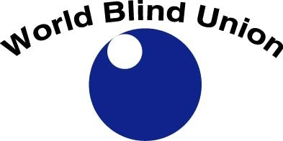

WORLD BLIND UNION
Changing What It Means to be Blind

ANNUAL REPORT
2009

www.worldblindunion.org

Message from the President
by Maryanne Diamond
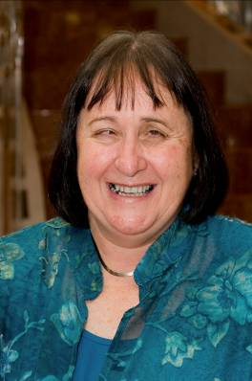
It gives me great pleasure to introduce the first Annual Report for the World Blind Union. We plan to produce an annual report for each of the four years during this quadrennium and a consolidated report at the end of the four years. This gives us the opportunity to reflect on what we have achieved in each year and what we have not and why and assist us in planning for the following year.

During December 2008, the officers along with a small group of resource persons met in the United Kingdom to develop our Strategic Plan 2009 – 2012. We drew upon: resolutions adopted at the 7th General Assembly, resolutions adopted at previous General Assemblies which had not been addressed, our Strategic Plan 2005 – 2008 and issues brought to our attention which would impact on the lives of people who are blind or have low vision in the coming years.

Our work is based around three priority areas: representation, capacity building and information sharing. This report outlines our work against these areas. In addition, to enable us to undertake the work in each of these priority areas, the plan contains one Enabling Priority.

As you read the report, you will see the large number of issues addressed by the WBU and how much there remains to be done.

A major area of our work which made tremendous progress and was undertaken by our members around the world, particularly led by Latin America and our Right2Read team, is the work done on the Treaty with WIPO. This work will continue in 2010. We are working towards a diplomatic conference to be held in 2011 to consider the Treaty.
The ability to share alternate format published works from country to country opens up opportunities in education, employment and access to the community for millions of people who are blind or have low vision.

One area of our work we hope to make great progress in during 2010 is our work in the area of employment. We plan to have determined how we will address the unacceptable levels of unemployment of people who are blind or partially sighted around the world, what we will work on and what our strategy will look like. Our focus will be at a global level but something which can be used at a local level.

We hope to build our resource base so that we can support people to build and strengthen our members and the work of the WBU.

I would like to thank the six Regional Presidents and 6 Table Officers for their leadership and hard work over the year. Particular thanks must go to our small but hard working staff: Penny Hartin and Ianina Rodriguez without whom we could not have achieved what we have in 2009. With the generous support from RNIB, Sarah Godwin worked with us during this year and I would like to thank her for her contribution and wish her every success in her future endeavours.

Special thanks must go to our sponsors and supporters who make it possible for us to undertake our work. There are huge, in-kind contributions at all levels provided to us which must be recognised and celebrated. These are drawn primarily from amongst our membership.

Without our diverse membership and regional structures we would not have the influence and recognition we have worldwide. I look forward to working with all of our members and partners in 2010.

We should celebrate and be proud of the great deal we have achieved. Of course, much more needs to be done to make the kind of change, we are all working towards, in the lives of people who are blind or partially sighted.

Our Work
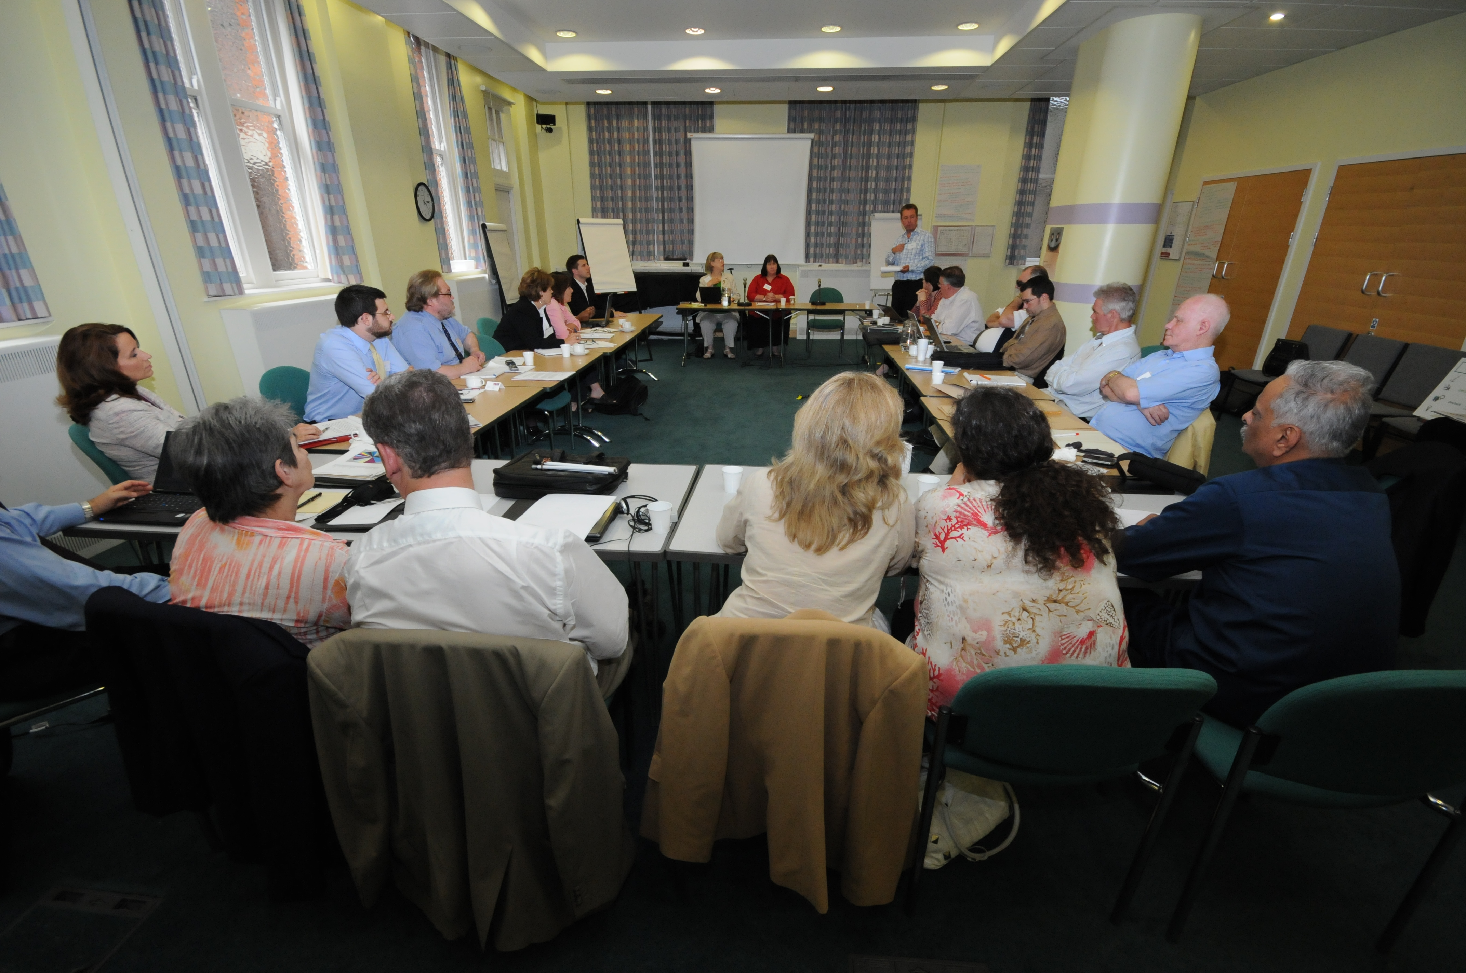
The work of the WBU during 2009 has been guided by our Strategic Plan which was developed in December 2008 and sets out our priorities and workplan for the 2009 to 2012 timeframe. The following pages discuss our Vision, Values and Priorities for the period as well as the work that has been undertaken so far in the advancement of those priorities. This report focuses primarily on initiatives undertaken at the global level. Our six WBU Regions also undertake a great deal of work within their regions to further these priorities and objectives. The specific Regions should be consulted directly for information about their specific initiatives and activities.

Our Vision

We have adopted a pyramid Vision structure which reflects our Vision of what we would hope to achieve within a twenty year timeframe as well as our Vision for this strategic planning cycle which is four years.
Our long term, twenty year Vision is:

A community where people who are blind or partially sighted are empowered to participate on an equal basis in any aspect of life they choose.

Our short term, four year Vision, has three ladders that together will move us towards the realization of our long term vision. These three Vision ladders are:

- That WBU is recognized as the authentic voice representing blind and partially sighted persons at the international level
- That our members at all levels have the capacity and capability to deliver their programs
- That the WBU is recognized as an international source of information in matters related to vision impairment

Our Personality

We are a worldwide community of blind and partially sighted persons that is inclusive, assertive and resourceful.

Our Values

- We value the abilities of people who are blind or partially sighted;
- We are an organisation which is: accountable, transparent, united, diverse, and professional and has integrity;
- We operate by being: respectful, honest, innovative, creative, trustworthy and responsive.

Strategic Priority 1: Representation

Strategic Priority Leaders: Ajai Kumar Mittal, Treasurer and
William Rowland, Past President

Promoting full participation and equal opportunities for blind and partially sighted persons in all aspects of social, economic, political and cultural life

Working towards a world accessible to blind and partially sighted persons

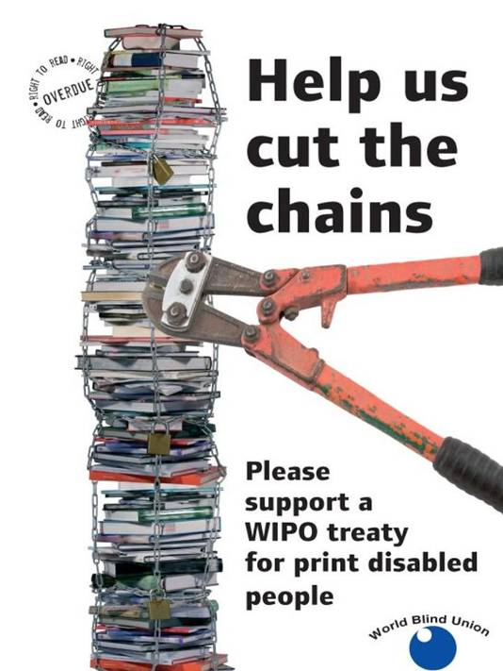Specific initiatives have been developed in the areas of access to information, mobility & transportation and access to technology.
A good deal of progress has been made in each of these areas under the leadership of Christopher Friend.

- The Right to Read Campaign, whose objective is to dramatically improve access to printed material for print handicapped persons has demanded a great deal of effort and has made significant progress. The WBU treaty has been brought forward to the SCCR (Standing Committee on Copyright & Related Rights) Committee of WIPO (World Intellectual Property Organization) and was the subject of discussion at its May and December meetings. Some good progress has been made to get countries “on board” but still there is much work to be done by our members at the international and national level. In addition, some countries have introduced Right to Read campaigns and have forged alliances to advance these
- Some of the issues being undertaken by the mobility & transportation group include: the issue of silent cars, shared spaces, access to airline services. With respect to silent vehicles, several manufacturers are beginning to understand the concern and are looking at ways to resolve the concern by introducing a detectable sound and other features. This will continue to be followed. The WBU and International Guide Dog Federation are looking at ways to work together to resolve some of the mobility and transport issues that continue to face blind and partially sighted persons. An area of key concern is the continued problem that many blind persons still face when travelling alone on airlines and this will be the subject of continued work
- The Technology working group has made some important progress in a number of areas: A good deal of effort has gone into making television accessible to blind and partially sighted persons through interventions with TV manufacturers and research work undertaken by RNIB. It is expected that an accessible digital TV prototype will be available later in 2010. The licensing of Tech share in other countries is bringing technology closer to blind and partially sighted persons in developing countries. A good deal of work has been done with mobile telephone companies so that many more models are now fully accessible to blind and partially sighted persons, including the new Apple iPhone and iTouch products. The WBU Technology working group has been working with the Accessible Design Foundation of Japan and the WBU has designated a representative to the ISO (International Standards Organization) working group dealing with the accessible design of products

Representing blind and partially sighted persons at the United Nations and UN Agencies

The WBU has consultative status with the UN Economic and Social Council and as such has the opportunity to participate in many sessions at the UN and its agencies. Some highlights of our participation over the past year include the following:

- 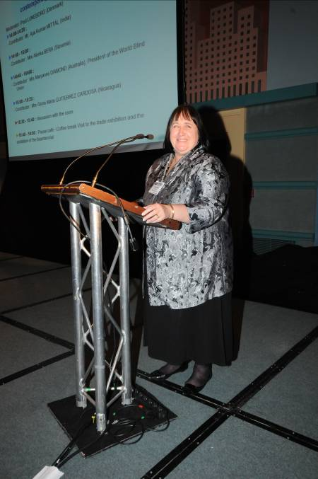The WBU was represented at both meetings of the CRPD monitoring committee that were held in 2009 and the WBU President also attended the Conference of States/Parties held in New York regarding the CRPD implementation
- We fulfilled all requirements to retain our consultative status with the World Health Organization
- The EBU President represented WBU at the Universal Postal Union (UPU) meetings to discuss the modernization of the “free post for the blind” provision
- The Chair of our Children’s network is an active participant on the UNICEF NGO committee on disability and recently represented WBU at the Commission on Social Development related to that
- WBU was represented by the CEO at the UNESCO Flagship meeting on the Education for All Persons with Disabilities program and made joint interventions with ICEVI on the EFAVI campaign
- WBU was represented at the World Bank GPDD (Global Program on Disability & Development) meeting of members and Board meeting and the WBU President has been elected to the GPDD Board
- WBU representatives have attended meetings with the World Health Organization to consult on such issues as the World Disability Report
- Discussions have been held with representatives from ILO in order to become more active with them and one of their disability consultants attended our Employment summit held in June 2009

Advocating for human rights of blind and partially sighted persons

A Human Rights and Advocacy working group has been established and they met to develop their course of action. In addition, the WBU took steps to advocate on behalf of blind persons who are displaced in Northern Pakistan as a result of the conflict there, as well as on behalf of persons with albinism who are being killed in Tanzania. Other letters were written by the WBU President in support of particular advocacy issues being undertaken by members, at their request.

Supporting our members to implement the CRPD at the national level

As of the end of December 2009, the status of CRPD signatories and ratifications was: signed-- 144; optional protocol--88; ratified-- 77; optional protocol—48 (the number of ratifications continues to increase). The WBU office is in the final stages of preparing a checklist, based on the tool developed by EBU, to support our national members in the implementation and monitoring process and this will be available early 2010. In addition, funding proposals have been developed and submitted for additional resources to support our members in CRPD implementation and monitoring processes.

Strategic Priority 2: Capacity Building

Strategic Priority Leaders: Arnt Holte, 1st Vice President and Frances Candiru, 2nd Vice President

Strengthening the capabilities and capacity of the WBU regional structures and member organisations

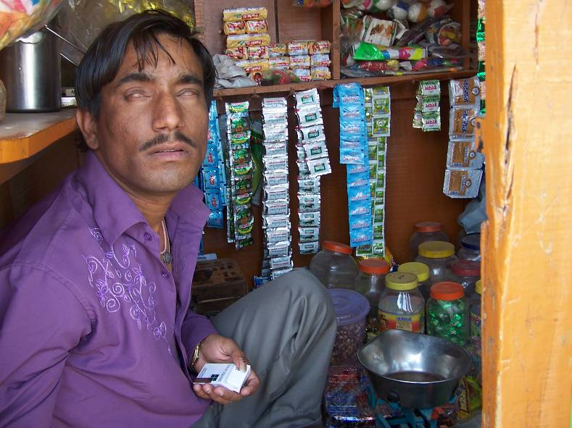Improving employment opportunities for blind and partially sighted persons
A Summit, bringing together some 25 leaders in the area of employment from around the world met in London in June in order to discuss the issue of unemployment among blind and partially sighted persons. As a result, a working group was established which has met to identify the key priorities for action and to develop specific initiatives to advance this work. A key barrier to employment continues to be attitudes among employers, families, teachers and blind persons themselves and so an area of focus will be the development of strategies and activities to help to change these attitudes which are key to getting and maintaining employment.

Developing the capacity of our members

The Development Committee has been re-established with the participation of members from key international organizations involved in development work. A proposal to engage a development coordinator has been developed and submitted to a number of potential sources for support. Although funding has not as yet been received, the proposal has generated some interest and work on that is being pursued by the WBU office. The Development committee is planning to hold a Development summit in Madrid in June of 2010 in order to further identify and articulate its plans for capacity building among our members. Some specific activities that have already taken place include: the development of a strategy for the distribution of 10,000 braille slates donated by the Italian Union of the Blind to developing countries; and the development of a partnership with the Hadley School for the Blind to promote its free educational programs to blind students worldwide and the promotion of its newly established Executive Leadership Program for blind leaders.

The Development Committee also oversaw the evaluation and approval of WBU scholarships from the Pedro Zurita Youth Fund, the Hermoine Grant Calhoun Scholarship Fund for Blind Women and the Arne Husveg Development Fund. In total they approved 12 scholarships for a total value of $9,800.

Supporting our target populations for full inclusion
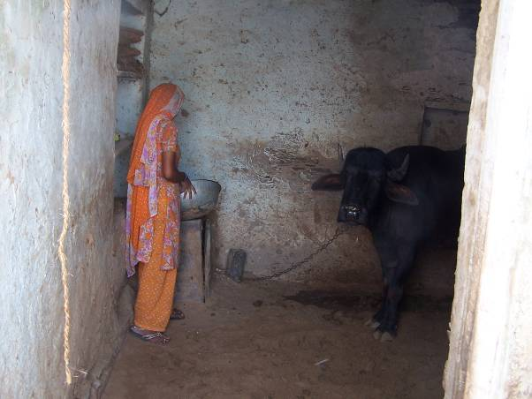
A Diversity Committee has been established, which is supported by Networks representing each of the target groups of; women, children, youth, elderly persons, persons with low vision and Indigenous persons. These networks have regional representation and are looking at ways to engage their target populations. In addition, the diversity committee has implemented a survey among WBU members to gauge the level of diversity among our member organizations.

Strengthening of World Braille Council
The World Braille Council has been reconstituted with representation from the major language groups with the WBU, from our Regions and from key stakeholder sectors. An initial meeting of the World Braille Council was held in Madrid in November 2009, under the leadership of World Braille Council Chair, Mr. J.L. Kaul from India. Some of the initiatives underway include the following:

- 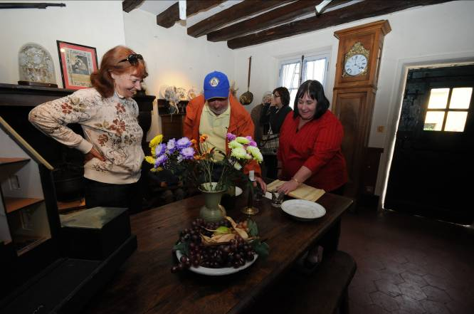A number of working groups have been established to look into issues of uniform mathematical symbols and notations; language issues; tactile materials for educational purposes; to promote establishment and support of national and regional Braille authorities; the development of a bibliography of Braille resource materials
- Materials are being gathered regarding the use of Braille on consumer products, etc., and best practices will be placed on the WBU website
- The Library of Congress in the USA is working with ICEB (International Council on English Braille) to begin work on the release of the 3rd edition of “World Braille Usage”
- A Conference is being planned for September 2011, hosted by The German Federation of the Blind and Partially Sighted with a number of sponsors from WBU members and partners

Strategic Priority 3: Information Sharing

Strategic Priority Leader: Enrique Pérez, Secretary General

Serving as an international information and resource centre on matters in respect of blind and partially sighted persons

Developing a Resource Repository for members including website

A good deal of work has been done to update the website and ensure materials are available in our three working languages. A new website structure has been designed and content is presently being developed for it. This should be ready for launching within the first half of 2010 and will be hosted on the Sharepoint platform which will be much more accessible, has features for website enhancement and provides us with more control over content design and management. In addition, proposals have been developed and submitted for the development of a resource repository which is dependent on additional resources being available.

Developing international partnerships and collaboration

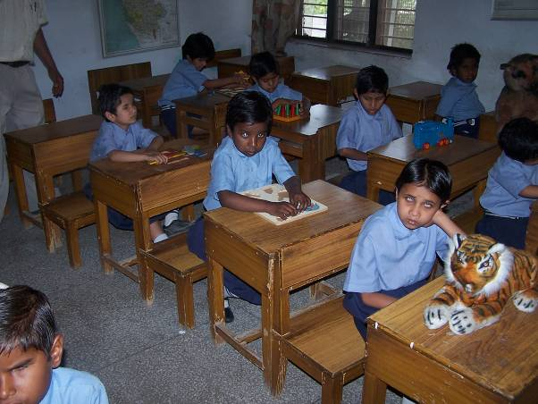Much work has been done to strengthen our partnerships and collaboration with other organizations. This includes the establishment of the Vision Alliance between the WBU, IAPB and ICEVI, which is now holding regular meetings and has developed some initial strategies for mutual collaboration. WBU continues to be an active member of the International Disability Alliance and has participated in all of its meetings during 2009. IDA has become a strong network, well recognized within the UN system.
We continue to work very cooperatively with ICEVI on the EFAVI campaign which has included attendance at all ICEVI Global Taskforce and Executive meetings, and joint presentations with ICEVI at UNESCO and the World Bank. We have also entered into discussions with IBSA (International Blind Sports Association) to explore areas of cooperation and collaboration and to update our memorandum of understanding between the two organizations.

Developing the capacity to include our various language communities within the work of the WBU

A languages working group has been established to examine strategies for improving our ability to serve our multiple language groups within the WBU. All materials intended for the website, the general public or for the full membership are now available in English, French and Spanish and correspondence is answered in the working language of choice. A volunteer from Jordan has also translated many of our documents into Arabic and these will be placed on the new website once it is launched. In addition, the office has tested and is using translation software which, although not appropriate for external use, facilitates the translation process for internal documents.

Enabling Priority: Effective Organization

Enabling Priority Leader: Maryanne Diamond, President

Ensuring the relevance, effectiveness, efficiency and sustainability of the WBU

Working to expand the membership

Five new membership applications were approved in 2009 and others will likely receive early approval in 2010. In addition, membership application materials are being developed for the launch of the new website in order to make the application process clearer and more streamlined.

Maintaining the membership

There is ongoing communication with WBU members on a number of topics and the Regional Unions are engaged to facilitate communication as appropriate. The frequent communication has resulted in improved fees payments and better quality contact information.

Coordinating the development of and reviewing WBU Policies and Position Papers

A policies working group has been established which has categorized the policies, determined those that need review and updating and a process has been developed for the policies papers updates. Once completed they will be translated and posted on the website.

Overseeing WBU financial resources

The Finance Committee has met on a regular basis to review financial statements and our position compared to the budget. The year 2009 was completed within the approved budget. A detailed operating budget was developed and approved for both 2009 and 2010.
The Finance committee also reviews policies and procedures to ensure compliance with proper financial practices.

A membership fees committee was established to manage the implementation of the new membership fee structure that had been approved by the General Assembly in August of 2008. The committee met both face to face and electronically to review and approve applications for reclassification of membership fee categories, for relief of fees and for transition periods to the new fee levels. The result of the deliberations of the membership fees committee resulted in a number of approvals for reclassification, fees relief and transition periods with the result that WBU received the highest level of membership fees revenue than ever. Regular follow-up with non-paying members and involvement of Regional Presidents also contributed to the first year positive results of the new program.

Developing and implementing the Funding Strategy

RNIB very generously provided WBU with a part-time fundraising resource to assist with the research and development of proposals.
As a result, three proposals based on strategic priorities were developed and a number of potential Foundations were identified.
The proposals were tailored to the requirements of each targeted foundation and approximately twenty-five proposals were submitted. Given the unfavourable economic conditions in 2009, these approaches were not successful, except for one which is presently at an advanced stage with a major Foundation. This work does, however, provide an excellent foundation on which to build our fundraising program.
In addition, a number of potential corporations were identified for approach in 2010. In addition, a strategy was developed for acquiring more Canadian funds in order to qualify for CIDA (Canadian International Development Agency) funding, for which we should be eligible in 2010. As a result of the work done in 2009 and the foundation set for 2010, a decision was made to redeploy the resources provided by RNIB and combine these with funds from our own budget in order to hire a part-time fundraiser to be based in the WBU office as it is believed that this will enable us to become more sustainable. This part-time fundraising position will be combined with some communications responsibility and will be resourced as a full-time dual responsibility position to be filled early in 2010.

In addition, the WBU President contacted all office sponsors for the purpose of renewing pledges for 2009, securing new sponsors and seeking extensions of sponsorship beyond 2010. We are delighted that Sightsavers came on board as a new Platinum sponsor and several of our sponsors agreed to an extension of funding beyond 2010.

Monitoring the effectiveness of the WBU operations to support its work
This work included the development of the bid process to host the 8th General Assembly in 2012, a process which is now well underway with bids having now been received and under review.

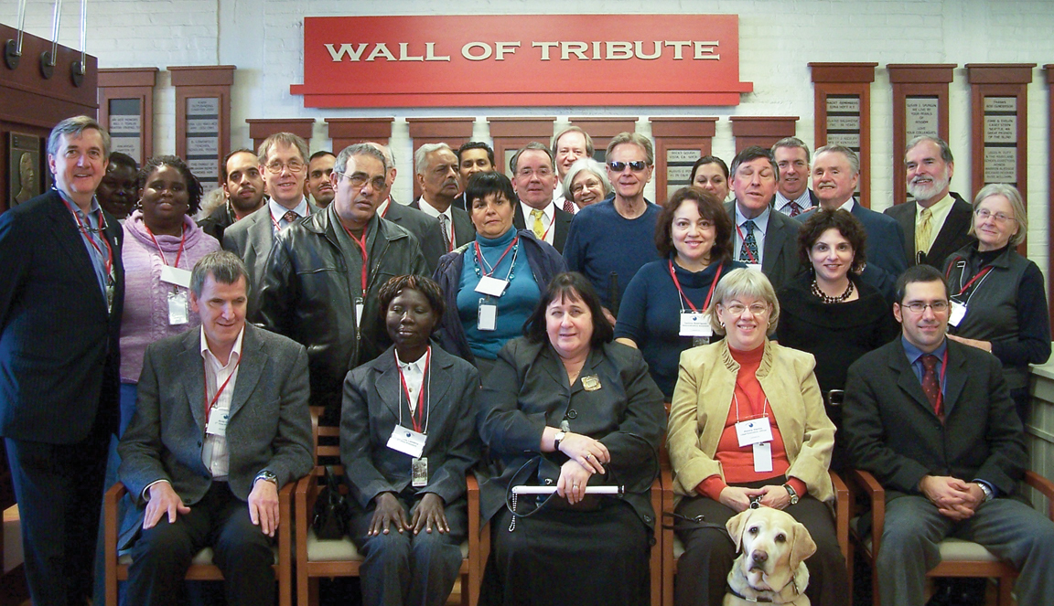In addition, the President worked closely with the CEO and office staff to monitor the performance and functioning of the office operations. This included regular email and Skype calls as well as face to face meetings whenever made possible by travel schedules. The President also provided regular updates to the Officers, held two face to face Officers meetings in 2009 and monitored the work of the Officers through their achievement of strategic objectives.

Celebrating the 200th Anniversary of the Birth of Louis Braille

The year 2009 was a landmark year for blind and partially sighted persons worldwide as it marked the 200th anniversary of the birth of Louis Braille, the inventor of the braille system of reading and writing still in use today in every country around the world.

The year was filled with celebrations around the world and included special art exhibits, conferences, the minting of braille coins, the issue of braille postage stamps, the naming of streets in honour of Louis Braille. A renewed interest in and passion for braille was sparked throughout the world.

At the site of the birthplace of Louis Braille, in Coupvray, France, a special celebration committee was established among organizations of the blind in France to spearhead the international celebration.
The celebrations began in Paris on January 4th, the birthdate of Louis Braille and included a visit to the Pantheon where his remains are buried. This was followed by a conference bringing together world leaders to discuss the use of Braille, its importance and future relevance. The conference resulted in a declaration that articulated a number of key actions important to the preservation and promotion of braille.

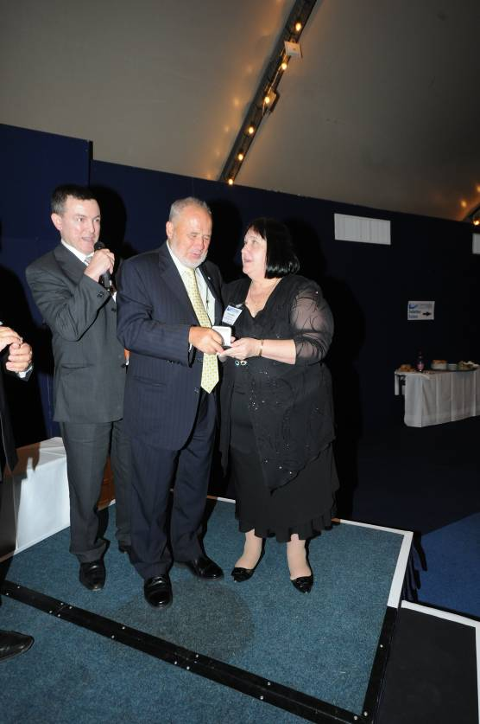In June, a second conference was coordinated near Coupvray that brought together international leaders to discuss education, employment, and cultural aspects of importance to blind and partially sighted persons. The WBU also took advantage of this opportunity where world leaders were gathered, to present the Louis Braille medal, which is presented only once every four years to an individual who has made a significant contribution to the lives of blind or partially sighted persons at the international level. We were honoured to present the Louis Braille Medal to Dr. Euclid Herie, a Past President of the World Blind Union who served as an international officer of the WBU from 1988 to 2004 and who was also the founder of the World Braille Foundation, which provides grants to small braille literacy projects in developing countries.

Our Finances

The following is a summary of our financial position. Please see our audited financial statements for detailed information.

Sources of Revenue
Membership fees 56.2%
Member donations 41.9%
Other revenue 1.9%

Use of funds
Capacity development 27.0%
Mission representation 21.9%
Information & education 19.1%
Membership activities 13.7%
Administration, fundraising & governance 18.3%

Our Key Supporters

Almost 100% of our funding comes from members at this time.
In addition to the membership fees paid by all WBU members, many of our members contribute to support our work in cash and in kind. Many members support our work through their support of staff or volunteers on WBU committees and working groups. We have no way of quantifying the monetary value of that support but know that it is significant to our operations.

The following lists voluntary monetary contributions from WBU members over and above their membership fees:

Platinum Sponsors
CNIB (The Canadian National Institute for the Blind)
ONCE (Organización Nacional de Ciegos Españoles)
RNIB (Royal National Institute of the Blind)
Also sponsorship of part-time fundraising resource, sponsorship of facilitation resource for Employment summit and contribution to World Braille Council
Sightsavers International
Vision Australia

Diamond Sponsors
NABP (Norwegian Association of the Blind and Partially Sighted)
Also sponsorship of guides for two Officers
RZNFB (Royal New Zealand National Foundation of the Blind)
SFB (Swiss Federation of the Blind and other partners)

Gold Sponsors
Unione Italiana Ciechi (Italian Union of the Blind)
National Industries for the Blind
Also, special donation to support Employment Initiative
Malaysian Union of the Blind

OUR WBU LEADERS

WBU OFFICERS
Ms. Maryanne Diamond, President
maryanne.diamond@visionaustralia.org
Mr. Arnt Holte,
1st Vice President
arnt.holte@blindeforbundet.no
Ms. Frances Candiru,
2nd Vice President
aiykko@gmail.com
Mr. Enrique Pérez,
Secretary General
umc@once.es
Mr. A. K. Mittal, Treasurer
akmittal@rediffmail.com
Dr. William Rowland,
Immediate Past President
rowland@sancb.org.za

REGIONAL PRESIDENTS
AFRICA (AFUB)
Mr. Mohammed Ez-zaoui
med.ezzaoui@gmail.com
ASIA (ABU)
Mr. Ahmad Mohammed Mousa Allouzi
fabjo@index.com.jo
ASIA PACIFIC (WBU-AP)
Mr. Chuji Sashida
sashida.chuji@jeed.or.jp
EUROPE (EBU)
Lord Colin Low
Colin.Low@rnib.org.uk
LATIN AMERICA (ULAC)
Dr. Guillermo Moreno
dr_guillermo_moreno@hotmail.com
NORTH AMERICA /CARIBBEAN (WBU-NA/C)
Mr. Carl Augusto
caugusto@afb.net

WBU STAFF
Dr. Penny Hartin,
Chief Executive Officer
penny.hartin@wbuoffice.org
Ms. Ianina Rodriguez, Administrative Assistant
ianina.rodriguez@wbuoffice.org
Committee & Working Group Chairs

Right to Read
Christopher Friend
Mobility & Transport
Sue Sharp
Technology
Stephen King
Human Rights & Advocacy
William Rowland & Colin Low
Employment
Maryanne Diamond
Development
Arnt Holte
Diversity
Frances Candiru
Wemen’s Network
Ileana Chacon
Children’s Network
Susan Laventure
Youth Network
Kerryanne Ifill
Elderly Persons Network
Alan Suttie
Low Vision Person’s Network
Jill Wagner
World Braille Council
J.L. Kaul
Languages
Guillermo Moreno
Policy Review
Enrique Pérez
Constitution
Enrique Pérez
Finance
A.K. Mittal
Membership Fee
A.K. Mittal
Nominations
Colin Low

CONTACT US

World Blind Union
1929 Bayview Avenue
Toronto Ontario
Canada M4G 3E8
Tel: 1 416 486 9698
Fax: 1 416 486 8107
Email: info@wbuoffice.org
Web: www.worldblindunion.org

