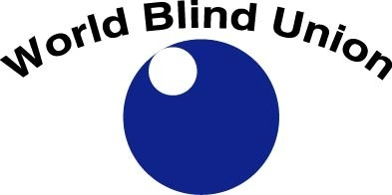

WORLD BLIND UNION
Changing What It Means to be Blind

ANNUAL REPORT
2017

www.worldblindunion.org www.wbu.ngo

Table of Contents

Message from the President 3
Our Work 5
Our Vision 7
STRATEGIC PRIORITY 1: Representation & Human Rights 8
STRATEGIC PRIORITY 2: Capacity Building 12
STRATEGIC PRIORITY 3: Accessibility 16
STRATEGIC PRIORITY 4: Information Sharing and Collaboration 20
ENABLING PRIORITY: Organizational Effectiveness 23
Our Finances 28
Our Key Supporters 29
Conclusion 30
OUR WBU LEADERS 2017 – 2020 31
WBU Officers 31
REGIONAL PRESIDENTS 31
WBU STAFF 31
Committee & Working Group Chairs 32
CONTACT US 32

Changing What It Means to be Blind

Message from the President

Dr. Fredric K. Schroeder, President, WBU
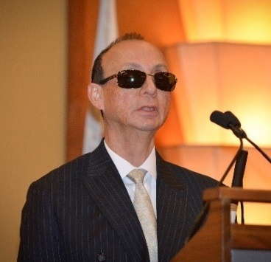
As you will see in this annual report, the World Blind Union continues to advocate strongly and effectively on behalf of blind and partially sighted people around the world. Our work is structured to address the myriad barriers we face to full integration.. The barriers we face are familiar and persistent: we face barriers that limit access to education, we face barriers that limit access to employment, we face barriers that limit access to social integration, we face barriers that limit access to living independently resulting from inaccessible home appliances and so on. Despite the challenges before us, we continue to make progress—significant and dramatic progress. A powerful example is our work to address the book famine.

In June 2013, our collective work led to the adoption of the Marrakesh book treaty. The Marrakesh treaty will give blind children and adults access to hundreds of thousands of books, and not just blind children and adults who live in the world’s richest countries but blind children and adults everywhere. To date, 35 countries have deposited their ratification documents with the World Intellectual Property Organization (WIPO). That means that 35 countries may now share accessible books and other works without violating national copyright law. BAs each country ratifies the Marrakesh treaty, it brings with it its collection of accessible books, expanding the collection, giving blind and partially sighted people greater access to print works.

But our work is far from over. We must work to convince more countries to ratify the Marrakesh treaty, and we must work to find new ways of getting accessible books to more and more blind people. This is why we led the initiative to develop a low cost refreshable braille display. With a low cost refreshable braille display, access to books expands from a handful of press braille books to thousands upon thousands of books.

The challenges we face are formidable, but the progress we have made and continue to make demonstrates that we will not stand by passively and watch the world go by. Blind and partially sighted people have the ability and the right to live as others, and our work forms the foundation on which our steady move toward equal opportunity is founded.

That is not to diminish or minimize the difficulties we face. Some of our challenges are social and others are structural and yet others are personal. In March, 2017, our beloved Second Vice President Elly Macha suddenly passed away. Elly was a champion in the truest sense of the word, and her death left a deep and sorrowful hole in our hearts. But our work goes on. Ms. Donatilla Kanimba, well known for her powerful and effective leadership as the Executive Director of the Rwanda Union of the Blind, was elected as our Second Vice President, bringing her experience and dedication to our collective work. We have experienced great success and we have suffered great loss, but we remain strong and committed to moving forward, step by step, ever closer to full and equal opportunity.

As you know, Dr. Penny Hartin has been our first and only CEO. Shortly after our 2016 General Assembly, Penny announced her intent to retire. That gave us time to conduct an orderly and thorough search for a new CEO. In April 2018, Mr. Jose Viera began his work as our second CEO. As we say in English, he has large shoes to fill, but Jose is a person of great ability and, like Penny, a person with a deep and unshakable belief in blind and partially sighted people.

In closing I wish to thank each of you for your work on behalf of blind and partially sighted people everywhere. We have and continue to make a difference. Each day, each month, each year we open new opportunities for blind and partially sighted people. Our progress is steady and unstoppable, and that is because of the individual difference each of you makes every day as we work to tear down each barrier that stands between us and full and equal participation.

Thank you for all you do.
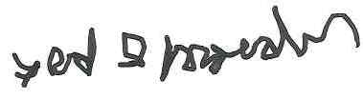
Dr. Fredric K. Schroeder
President, World Blind Union

Our Work

Following the process established following the 6th WBU General Assembly in 2004, a few months after the 2016 General Assembly held in Orlando USA, in November 2016, the newly elected WBU Officers, supported by several resource persons, met to develop the Strategic Plan that would govern the work of the Union for the 2017 to 2020 period. This strategic plan was then operationalized through the development of a detailed work plan which articulated objectives, initiatives and action plans for each of the five priority areas. The achievement of this work plan formed the basis of the agenda for each Officers meeting held in 2017 and forms the basis of this Annual Report for 2017.
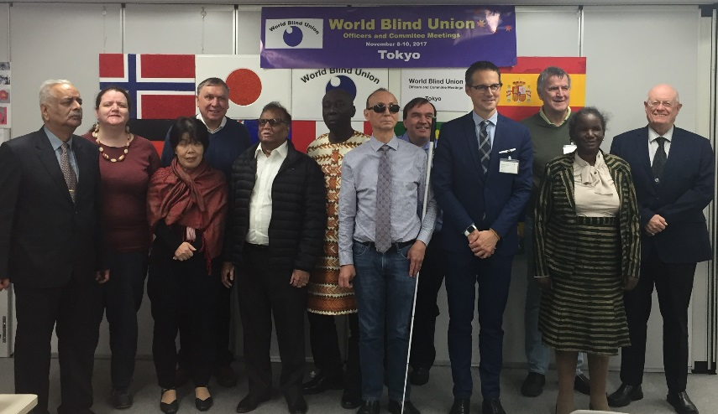
Officers meeting in Tokyo November 2017
The following pages provide an overview of the priorities that were identified and our work in advancing those priorities so far in the quadrennial. And while some of the work is still getting underway, there is still nevertheless a good deal to report on progress to date. While this report focuses primarily on initiatives undertaken at the global level it is important to recognize the significant contributions of our Regional Unions in achieving our objectives and advancing our work.
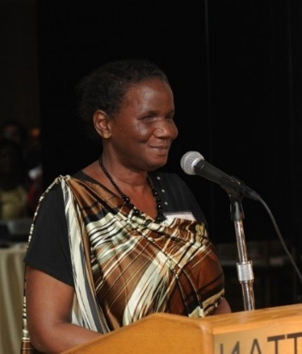
Donatilla Kanimba, 2nd Vice President
2017 also marked two significant events for the WBU. In March 2017, we suddenly and tragically lost our 2nd Vice President, Dr. Elly Macha, who unexpectedly passed away after a short illness. Because this sad event occurred so early in the quadrennial period, the WBU Executive took the decision to undertake an election process for a new 2nd Vice President. We were delighted when Ms. Donatilla Kanimba, well known to WBU as Executive Director of the Rwanda Union of the Blind was elected. Another significant event was the recruitment of a new Chief Executive Officer following the announcement of our current CEO, Dr. Penny Hartin, of her intention to retire in the first half of 2018. We were delighted at the interest demonstrated in this key position and that José Maria Viera from Argentina was the successful candidate. José took up his post in mid-April.

Our Vision

The WBU has a pyramid Vision structure which reflects our Vision of what we would hope to achieve within a twenty-year timeframe as well as our Vision for this strategic planning cycle of four years.
Our long-term Vision is:
A world in which we, as blind or partially sighted people, can participate fully in any aspect of life we choose

Our short term, four-year Vision, has four ladders that together move us towards the realization of our long-term vision. These four Vision ladders are:
- That WBU is recognized as the authentic voice representing blind and partially sighted persons at the international level
- That our members at all levels have the capacity and capability to deliver their programs
- That blind and partially sighted persons live in a world that is increasingly accessible to us
- That the WBU is recognized as an international source of information in matters related to vision impairment

Here then is a summary of what we have achieved so far within our four strategic priority areas of: Representation and Human Rights, Capacity Building, Accessibility and Information Sharing and Collaboration, as well as in our Enabling Priority of having an Effective Organization.

STRATEGIC PRIORITY 1: Representation & Human Rights

Strategic Priority Leader: Fernando Riaño, WBU 1st Vice President
“Promoting full participation, equal opportunities, and protecting the human rights of blind and partially sighted persons in all aspects of social, economic, political and cultural life and ensuring that our voice is heard at the global, regional and national levels in all matters affecting our lives.”
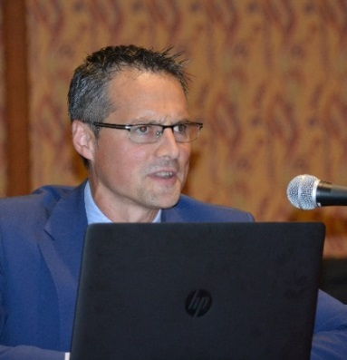
Fernando Riaño, WBU First Vice President
Our first Strategic Priority reflects the important role the WBU plays in representing the needs and views of blind and partially sighted people within the international arena, particularly the UN system, as well as the important role we play in advocating for the human rights of blind and partially sighted persons.
Strategic Objectives:

Representing Blind and Partially Sighted Persons at the United Nations and relevant UN Agencies and Treaty bodies at the global and regional levels

The WBU continues to take an active role in representing blind and partially sighted people to the UN and relevant agencies. Where appropriate, we have joined our voice with the International Disability Alliance (IDA), the International Disability & Development Consortium (IDDC) and other Vision Alliance members on those areas of mutual interest. However, we also make our own statements when we consider it important to highlight unique issues facing blind and partially sighted people.

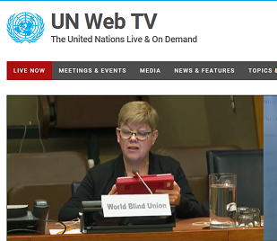
Dr. Penny Hartin, Retiring WBU CEO addressed the UN at International Day of Persons with Disabilities opening ceremonies at the UN Headquarters, New York, 1st December 2017
Some significant undertakings since the beginning of the quadrennial include the following:
- Participation at the High Level Political Forums to the SDG’s in both 2016 and 2017, including support to members whose countries are making reports and being part of panel presentations;
- Submissions to the CRPD committee on General comments 5 and 19 as well as presenting to CRPD committee by Marrakesh Implementation Guide author, by invitation of the Committee;
- Active involvement with World Health Organization (WHO) on the development of the World Report on Vision to be released later in 2018;
- Submission of an interim triennial collaboration report to WHO, focusing on the agreed areas of collaboration;
- Our Regional Unions have also taken an active role in UN representation work at the regional level with ABU and WBUAP regions actively involved in the implementation and monitoring of the Incheon Strategy; ULAC obtaining special consultative status with ECOSOC; and AFUB becoming actively engaged with the African Union and the African Decade of the Disabled
- We have been very active in promoting international Days of relevance to us. In particular, we have been developing messages for: World Braille Day, International Women’s Day, World Copyright Day, International White Cane Safety Day, World Sight Day, International Day of Persons with Disabilities and International Human Rights Day. We are also working with a friend of WBU who is an ambassador at the UN to get recognition for World Braille Day as a UN international Day. We hope to have this in place in 2018.
Ensuring that the WBU and its members are actively engaged in the implementation and monitoring of the UN Convention on the Rights of Persons with Disabilities (CRPD) at both the international and national levels.

The focus of this work is to inform WBU members about the CRPD and how they can utilize it to support their own advocacy efforts. Through the engagement of our WBU Human Rights Policy Advisor, a position supported by CBM, we have been able to undertake a number of initiatives. These include:
- Participation in a global mapping exercise undertaken by the Zero Project to map CRPD implementation worldwide. About 12 of our WBU members participated in this study.
- The Human Rights Policy Advisor conducted several online webinars for members to deepen their understanding of CRPD; and members were reminded of and encouraged to use the CRPD FAQ sheets and CRPD toolkit developed by WBU several years ago and available from the WBU website;
- The Human Rights Policy Advisor identifies countries that are scheduled for review by the CRPD Committee; offers assistance to those countries in developing parallel reports and supporting their advocacy efforts with other disabled persons organizations in their countries. Many countries have participated in these opportunities although we have noted a lack of follow through from several of them.

Ensuring that the WBU and its members understand the implications and opportunities provided by the Sustainable Development Goals (SDG’s) and proactively engage in their implementation and monitoring process at all levels

The agreement of the Sustainable Development Goals (SDG’s) has opened up additional opportunities for inclusive development for people with disabilities. While the CRPD is the overarching framework to address some of the current areas of discrimination that face people with disabilities, the SDG’s represent concrete commitments and actions for governments to take that will, if implemented, help to improve the situation for people with disabilities in certain areas. A key aspect of our work in this area has involved informing members about the SDG’s and the 2030 agenda and how these interact with the CRPD. Some specific initiatives have included:

- The WBU Human Rights Policy Advisor played a key role in the IDA task force coordinating DPO engagement in the National Voluntary Review Process and took part in the HLPF in both 2016n and 2017.
- Tools and key messaging are in the process of being developed for members and several webinars have been conducted for members in Latin America and Africa regions to provide initial awareness and training on the SDG’s.
- Members are supported through bilateral online meetings to prepare for their country’s national voluntary reviews and encouraged to work with other DPO’s as part of the process.
- The WBU CEO also participated in meetings held in Ottawa and New York that examined how data would be collected to ensure measurement of progress for people with disabilities in the realization of the SDG’s.

Advocating for and promoting the human rights of blind and partially sighted persons

Our initiatives focus on strategies to strengthen WBU’s role in the areas of human rights and advocacy, including the provision of advocacy support in situations of serious human rights abuses or where blind persons are particularly vulnerable. Some of the specific work underway includes:
- Working with members whose countries are scheduled for review under the Universal Periodic Review Process by the Human Rights Council. Many members have expressed interest in engaging in this process and the Human Rights Policy Advisor is assisting with this.
- The Human Rights Committee is in the process of examining ways to identify and document Human Rights issues and violations as well as examining the most appropriate role for WBU to play as well as other international organizations who may be able to assist us with this work.

Engaging with members, other stakeholders and international development organizations to protect the rights of blind and partially sighted persons in situations of disaster, humanitarian emergency or conflict and to ensure that all services and programs are accessible to them.
- Guidelines for organizations and for individuals have been drafted and are in the final stages of revision before being translated and shared with members.
- WBU is taking an active part in an IDA project that is being coordinated by CBM and Handicap International and is looking at strategies and best practice regarding humanitarian assistance and disaster risk reduction.

STRATEGIC PRIORITY 2: Capacity Building
Priority Leader: Arnt Holte, WBU Immediate Past President

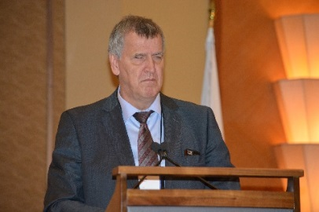
Arnt Holte, WBU Immediate Past President

“Strengthening the capabilities and capacity of the WBU regional structures and member organisations”

Strategic Objectives:

Improving employment opportunities for blind and partially sighted persons
As was the case during the last quadrennial workplan period, the WBU has retained its priority of improving the employment situation for blind and partially sighted people. Some of the work undertaken by the WBU Employment committee so far includes:
- Continuous work on our Project Aspiro website to ensure its currency and usefulness to blind and partially sighted job seekers, family and service providers and potential employers. This work has included the promotion of Project Aspiro via the WBU E-bulletin and the addition of several new success stories from different parts of the world that feature the range of employment opportunities that blind and partially sighted people are engaged in. We increased the number of visitors to the Project Aspiro site 10.2% over last year., a good indication of the continued relevance and utility of this resource.
- Members are being encouraged to share best practice models and more work is being planned in this area.
- Some of our WBU members have partnered to conduct research into the facilitators and barriers related to employment of blind and partially sighted people. It is expected that preliminary research findings will be available in late 2018 and which will no doubt prove very helpful to future planning.

Work to ensure the sustainability of the WBU Regions

The six WBU Regional Unions have different structures and funding models – three of the regions have functioning secretariat offices while the other three rely on the voluntary support of their elected officers, supportive members within their regions and so forth. And those regions that have full time offices face challenges to maintain and attract new funding to support their regional operations. A working group has therefore been established to examine these issues and consider strategies to support the ongoing sustainability of our regional structures as well as mechanisms for sharing expertise and resources. This work has commenced but is still very much in the planning stages.

Improving the capacity of our member organizations, including our International members, to engage with each other to facilitate interactions, resource sharing, and working collaboratively

The Development Committee has made it a priority to promote cooperation and partnerships between organizations involved in international development and the WBU. The Committee is also examining strategies to build on the good work from past terms with a focus on strengthening the overall capacity of our members. Some of the initiatives undertaken so far include:
- The Resource manual on international development aid program developed during the last quadrennial has been translated, placed on the website and is being promoted to members as a valuable tool and resource for their use.
- The Development Committee has undertaken a survey among WBU members to understand their experience with blindness-specific disability versus cross disability rehabilitation service programs. This survey should be completed mid-year and its results will inform a joint strategy between the development and rehabilitation committees.
- A seminar is being planned for the WBU EXCO regarding building awareness of and implementation strategies for the UNCRPD and the SDG’s, co-planned by the Development Committee and the UN Advocacy network.

Supporting our target populations for full inclusion

The WBU has had, as a priority for many years, the support of our diverse population groups to facilitate their inclusion within WBU and that their needs and views would be considered in programs and services. While in prior quadrennial periods, this work was undertaken within a larger diversity committee that sought to encompass all these target groups, we determined that this approach was not particularly effective and did not advance the situation for any of the target groups in a measurable way. Consequently, distinct committees or working groups have been established to consider the unique needs of blind and partially sighted women and girls, of youth, of older persons and of people with low vision. Here is a summary of some of the work these groups have undertaken so far:

Women’s Committee
- The Women’s committee has developed criteria and terms of reference for the Women’s Empowerment Award that was approved by resolution at the 2016 General Assembly and which they expect to award at the 2020 Assembly.
- A survey has been conducted among blind and partially sighted women throughout our membership to determine their participation and engagement at various levels of the WBU structure as well as the unique issues they face. This survey is currently being analysed and its results will inform future action by the committee.
- The WBU will take an active, leadership role in a Women’s leadership project being coordinated by the International Disability Alliance (IDA). This work is just getting underway.

Youth Committee
- The Youth committee has identified several strategies to promote and encourage more involvement by blind and partially sighted youth including attendance at the General Assembly, regional youth workshops etc. Most of these initiatives are under development.
- The Youth committee has also identified ways to help support and strengthen WBU’s communications vehicles (social media, E-bulletin articles, Facebook, etc.) and has also identified youth members to serve on other WBU committees to provide a youth perspective to their work.

Elderly Persons Committee
- While it took some time to get the Elderly Person’s committee underway, they are now in place.
- The committee has developed a survey for members to examine issues faced by elderly blind and partially sighted persons and how they are included in our WBU work. This survey will be completed and analysed during 2018.
Low Vision Committee
- The low vision committee has reviewed and confirmed the joint low vision policy statement developed by the Vision Alliance in 2015.
- The Committee has undertaken a survey, both of organizations and of individuals, to determine the unique issues faced by persons with low vision and how they are included and their needs reflected by WBU member organizations. Many responses have been received for this survey which will be analyzed in the first half of 2018.
- The Low Vision Committee has also established a shared dropbox folder for the sharing of tools and resources.

Improving access to rehabilitation services by blind and partially sighted persons

Access to appropriate habilitation and rehabilitation services is very important to blind and partially sighted persons to enhance independence and full participation.
- The Rehabilitation committee is in the process of designing a follow-up questionnaire that will expand on the information obtained from the rehabilitation survey conducted in 2015.
- A template has been drafted to capture information from members about rehabilitation programs within their countries. When finalized and information gathered, this will be included on the WBU website.

STRATEGIC PRIORITY 3: Accessibility

Priority Leader: Ajai Kumar Mittal, WBU Secretary General
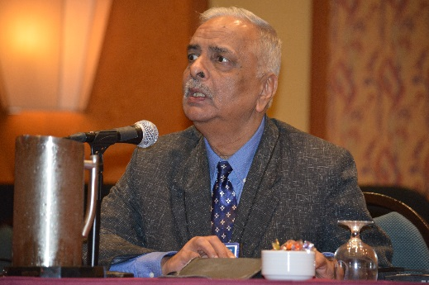
Ajai Kumar Mittal, WBU Secretary General
“Working towards a world that is increasingly accessible to blind and partially sighted persons”

Strategic Objectives:

Improving Access to Information for blind and partially sighted persons

The promotion and implementation of the Marrakesh Treaty has continued to be a major priority for us. Once the Treaty came into force in September 2016, we shifted our focus to appropriate implementation of the Treaty as well as securing as many ratifications as possible.
- As of mid-April 2018, thirty-five countries have ratified the Marrakesh Treaty. Given the EU’s commitment to ratify the Treaty, confirmed in February 2018, we expect that the administrative requirements for ratification will be met sometime this year and are therefore optimistic of EU formal ratification during 2018. Also, given recent developments in the United States, we are also optimistic of US ratification this year.
- The two-year project funded by Open Society Institute ended officially on December 31, 2017. This project, which provided $300,000 over two years, was of huge assistance to us in supporting regional initiatives and in developing and implementing several global projects to support the Marrakesh Treaty objectives.
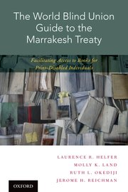
- The Marrakesh Implementation Guide was published by Oxford University Press; has been translated into several languages with the support of several of our members, and is available on-line from the WBU website as well as for purchase from Oxford University Press. We acquired several hundred copies of the guide which were given out to the Regions, as part of training programs and to copyright officials attending the May 2017 WIPO Standing committee on Copyright and Related Rights (SCCR) meetings.
- A week-long training program focused on the Marrakesh Implementation Guide was conducted at the WBU office in Toronto in April for over 20 regional representatives, all of whom were given the mandate to return home and deliver local training on Marrakesh and the tools we have available.
- We were successful in securing a pro bono project through Trust Law legal services that researched the readiness of some ten countries with respect to their readiness to implement the Marrakesh Treaty.
- WBU continues to play an active role in the WIPO’s Accessible Books Consortium (ABC) with the Chair of the WBU Right to Read Campaign currently serving as Vice Chair of ABC. ABC is focusing on building the Global Book Service and building capacity for accessible book production in developing countries. As of the end of 2017, the number of titles in the ABC catalogue was 376,500. Thus far, over 165,000 blind/print disabled persons have received materials through ABC’s Global Book Service.
- The Right to Read committee, in cooperation with the DAISY Consortium and others continues to support inclusive publishing initiatives so that materials will be “born accessible”.

Promoting access to low and high technology solutions for blind and partially sighted persons, including household and consumer goods

The Technology Committee is examining strategies to improve access for blind and partially sighted people to the full range of technology devices and services from autonomous vehicles and accessible computer software and mobile phones to accessible household appliances and self-serve kiosks. In a world where technology is changing rapidly and more and more services and devices being powered by these technological advances, it is critically important that we are aware of the developments and advocate for accessibility at every stage of development so that previously accessible tasks don’t become inaccessible for us.

Some of the specific initiatives undertaken by the technology committee include the following:
- With respect to advocacy around accessibility of autonomous (self-driving) vehicles, a messaging document has been developed to ensure that all advocates are conveying the same messages to manufacturers and legislators. In addition, discussions are taking place both with automobile manufacturers to advocate for full accessibility of the autonomous driving interface as well as with lawmakers to ensure that no unnecessary barriers are created to enable blind and partially sighted people to operate these vehicles once they become fully autonomous.
- A good deal of work has been done with Microsoft to advocate for improved accessibility of all its products and services and the WBU technology committee has been invited to submit a list of suggestions to the Microsoft Engineering department. The committee is also working on similar discussions with Apple and Google regarding the accessibility of their products.
- With respect to access to household goods, touch screens and self-service kiosks, the committee is taking a three-strand approach to this work: 1) access to packaging, instructions and printed material, 2) accessibility of visual/touch screen displays, and 3) accessibility of operating interfaces. A comprehensive survey will be created to identify available solutions and understand the requirements of innovation and having the existing technologies. Governments will be engaged to change their procurement policy of public utilities and services in accordance with principles of universal design.
- In terms of access to more affordable mobile technology, the committee decided the most effective approach now would be to research and record the access features currently built into equipment and provide support and advice to manufacturers regarding accessibility as needed.

Promoting full access to the environment for blind and partially sighted persons including safe and independent travel and access to transportation

Our strategies for improving access to the environment include several aspects: continued advocacy related to silent/hybrid cars, improved access to air travel, barrier-free universal design and issues related to shared spaces. Here are some of the specific initiatives underway:

- Work to achieve a technical regulation regarding a minimum sound standard for quiet/hybrid vehicles has been delayed due to pending US legislation. Our concerns regarding minimum sound levels and having an alert sound when the vehicles are stopped at intersections, for example, are not yet fully resolved. This work remains ongoing and active.
- We have been following closely the issue of fake service dogs as well as non-trained therapy and comfort dogs which are posing challenges for legitimate guide dog users to travel with their trained guide dogs. We are working closely with International Guide Dog Federation and other service dog organizations to advocate for proper recognition of trained guide dogs.
- In an effort to promote more inclusive tourism and access to culture, the Access to the Environment working group is taking an active role in the program committee for the Destinations for All Accessible Tourism conference that will be held in Brussels later in 2018. In addition, in cooperation with Joel Snyder from ABC Audio Description services, we have conducted a survey among our members regarding their access to audio description for TV, film and cultural events. We expect to have results from this survey shortly.
- We have developed relationships with Wayfindr to support indoor navigation technology as well as with Universal Design Foundation to continue to promote universal design in all aspects of building and environmental design and construction.
- Work is ongoing to promote the shared spaces policy paper developed during the last term and the Chair of the Access to the Environment committee had the opportunity to present it at the Vision 2017 conference held in The Hague in June 2017.

STRATEGIC PRIORITY 4: Information Sharing and Collaboration
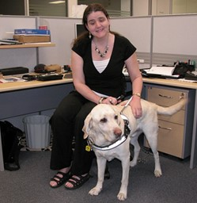
Martine Abel-Williamson, WBU Treasurer
Priority Leader: Martine Abel-Williamson, WBU Treasurer
“Supporting and enhancing our advocacy, representation and capacity strengthening efforts through raising awareness and support for our campaigns and initiatives, providing information and resources on matters important to blind and partially sighted persons and collaborating effectively with others.”
Strategic Objectives:

Developing and making available a variety of resources to our members and the public through a variety of communications channels

Through the efforts of the new WBU Communications Officer and the newly established Communications Committee, several initiatives have been undertaken to strengthen WBU’s communication capacity. These include:
- A communications strategy has been developed to support the WBU Strategic Plan and to focus on our various communications channels including the website, social media, the E-bulletin and campaigns to focus on specific international days and key priorities.
- A new Vision Health section has been added to the WBU website with a wide range of resources and information related to vision health. Other improvements to the website include the development of a landing page for our WBU Friends initiative, ensuring links to our social media channels and improving consistency of our three language sites. Our analytics show a steady increase in visitors to the WBU website.
- The Communications Committee is also looking at ways to promote the various tools, resources and policy papers included on the website. This work will include the development of a resource guide to inform members of what is available as well as highlighting resources by means of the quarterly E-bulletin.
- A Social Media sub-committee has been established to maximize our presence on social media – in particular, Twitter and Facebook. Their work has included the development of an annual calendar to promote various international days and aspects of our work and translation of some of the key messages. Our social media channels have now been easily linked from our website.
- Strategies have also been implemented to promote the various WBU priorities and achievements and to more actively engage members in communications.

Developing and strengthening international partnerships and collaboration

Partnerships with other organizations continue to be very beneficial to WBU in many areas of our work. Some examples of these partnerships include the following:

- While the Vision Alliance has been less active in the past year or two, it is nevertheless seen as an important collaboration and all three organizations recognize its value and intend on retaining the Alliance. A face to face meeting is planned in conjunction with the EXCO meeting in Ottawa in March.
- WBU continues to be an active member of the International Disability Alliance. The WBU President will shortly be assuming the WBU representative role on the IDA Board and the CEO serves on the IDA Program committee. WBU has been represented at all Board and program committee meetings and works hard to ensure that opportunities made possible through IDA projects are equally available to blind and partially sighted persons through our national and regional members.
- After 25 years of active involvement in the IDP (institutional development program), a decision has been taken by the partners to close out several aspects of this program due to unsustainable funding. It is the intention of those partners involved, however, that the Africa Forum, which is held about every four years is an important program that will be retained.

Promoting and advancing the use of braille through the work of the World Braille Council

The World Braille Council continues to be an important standing committee of the World Blind Union as we develop and implement strategies to raise awareness and promote braille; and to bring it to more blind people around the world, particularly in developing countries. Some of the initiatives being undertaken by the World Braille Council include:
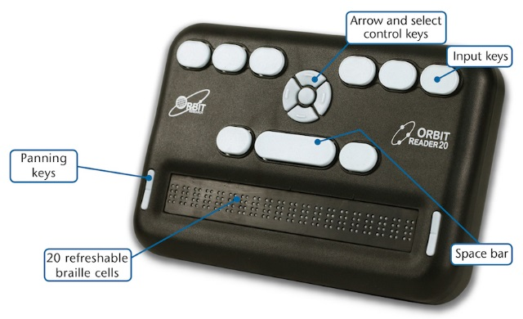

- The new low cost refreshable braille display, Orbit Reader, is being promoted with the hope that it will be available in developing countries.
- The Dolphin Easy Converter that enables conversion of documents into accessible formats is now available at no cost for developing countries. It is presently being promoted to WBU members that qualify although more promotion needs to be done as the uptake isn’t as much as had been anticipated.
- The Council is working on a document to study the benefits and opportunities of transitioning to refreshable rather than paper braille.
- Plans are underway for the transition of World Braille Foundation to World Blind Union, under the direction of World Braille Council, during 2018.

ENABLING PRIORITY: Organizational Effectiveness

Priority Leader: Dr. Fredric Schroeder, WBU President

“Ensuring the relevance, effectiveness, efficiency and sustainability of the WBU”

Enabling Objectives:

In cooperation with the Regional Unions, supporting the members of the WBU to optimize their representation of blind and partially sighted persons.
Work is ongoing, by the Secretary General and the WBU office to manage the membership matters for WBU. Some highlights include:
- A process is in place to acknowledge, track and process applications for membership with most being dealt with in a timely manner although there remain some follow-up issues with some regions.
- We continue to work with members who have not paid their membership fees in several years to arrive at solutions with them and bring them back on board, including offering suggestions such as the sharing of membership with other organizations in their country. This is an ongoing issue for some members.

Overseeing WBU financial resources

Oversight of WBU’s financial position is an important governance role of the Officers and the WBU corporation in Canada, and therefore, initiatives are included that relate to the preparation and review of financial documents, review, and development of financial policies and procedures and continuous monitoring of the financial health of WBU. As a membership organization that relies on membership fees as an important source of revenue, the process of monitoring membership fees is also included in this work.

- The Finance committee continues to meet prior to all Officers meetings to review and recommend for approval quarterly and annual financial statements as well as the annual operating budget. The financial operations continue to be managed well with a small surplus forecast for 2017 despite having to write down some unpaid membership fees from the last quadrennial as well as losing one platinum core sponsor and another major donor.
- Financial processes are monitored and recommendations from the auditors taken on board (in the last few years there have been no recommendations for policy improvements since the auditors are happy with the systems and processes in place); the finance committee has also been reviewing any signing authority and credit changes that will be required as part of the transition to the new CEO.
- The membership committee continues to meet to review applications for fee relief and have recently approved applications for renewal of fee subsidies for this current quadrennial period, with 16 requests approved.

Developing and implementing strategies to generate resources to support the work of the WBU

In order to ensure the WBU remains strong and sustainable into the future, it is important for us to generate funds in addition to our membership fees, both inside and outside the organization. In addition to covering the costs of our small office, including accounting, insurance and so forth, the annual operating budget also allocates a significant amount to support members from developing countries to participate in WBU’s work, including putting funds aside to support attendance at the next General Assembly, costs of translation, website and other related costs. Membership fees alone only constitute about fifty percent of these costs.

- We continue to be grateful to our core sponsors for their continued support. However, one of our platinum level sponsors discontinued funding support in 2017 and no other members have come on board as core sponsors. The resource generation committee will need to look at our core support needs as a key priority to ensure future sustainability.
- We continue to receive support from CBM for our Human Rights and Advocacy work – this project is now in its sixth year. We are very grateful for the ongoing support without which we would not be able to operate this important program.
- Our two two-year projects related to the Marrakesh Treaty campaign and funded by the FOSI Foundation came to an end in December 2017. Since 2014, we received some $460,000 from that Foundation to support our work which helped advance our Marrakesh campaigns tremendously. We have established our eligibility for the FOSI Foundation so it will be possible to look at other projects with them in the future.

Undertaking a review of the WBU membership fees structure

- As requested through a resolution adopted at the 2016 General Assembly, a review was undertaken of the current membership fee structure to determine if there was a more convenient and equitable way to charge membership fees while still generating the same or more revenue to support the WBU operations. It should be noted that a comprehensive review of the membership fee process was conducted in 2007 and a new structure approved by the General Assembly in 2008 and implemented from 2009 onwards. This new structure was reviewed in 2010 by the WBU Executive which concluded that the new fee structure was working as planned.
- As directed by the 2016 resolution, a review task force was struck and met in May 2017; its review concluded that our current structure was fair and transparent and had sufficient flexibility to accommodate the unique needs of members if needed. Any significant changes would result in significant constitutional implications with little additional income foreseen. The task force therefore recommended no changes to the present membership fee structure. This recommendation will be presented to the WBU Executive when they meet in May 2018.

Monitoring and evaluating the effectiveness of the WBU operations to support its work
Effective organizations continuously monitor the effectiveness of their operations, structures and processes. For WBU, this includes management of the staff and office, monitoring the strategic planning and reporting process and ensuring policies and procedures are current and reflect requirements.
- Following the 2016 General Assembly, an evaluation was undertaken by both WBU and ICEVI to determine if they would continue with a joint Assembly in 2020. The result of the evaluation and discussions was an agreement that a joint Assembly would be held in 2020. The Bid documents were accordingly revised and sent to members in August 2017. Three bids were received to host the 2020 Assembly. Two locations were chosen for site visits and it is expected that a recommendation will be submitted to the Executive at their meeting in May 2018.
- There have been three meetings of the Officers held since the General Assembly: November 2016, which was also a planning meeting for the term and held in Baltimore USA, May 2017 in New Delhi and November 2017 in Tokyo. In addition, the Executive was required to make certain decisions via email. This included an email ballot conducted in August 2017 to elect a new 2nd Vice President, following the untimely and sudden death of Dr. Elly Macha.
- Following the development of the strategic plan for 2017 – 20 at the November 2016 Officers meeting, a detailed workplan was developed in cooperation with the Committee and Working group chairs and its monitoring forms part of the agenda for each Officers meeting.
- All the legal aspects of the WBU corporation in Canada are monitored with all required reporting in place and Corporation meetings held as required, normally in conjunction with the Officers meetings. We have undertaken discussions with our legal counsel regarding the processes to be followed regarding the impending dissolution of World Braille Foundation and the transfer of WBF assets to the World Blind Union during 2018. Having the legal corporation in Canada allows for a smooth transition in this process.

Developing and implementing a leadership program for future WBU leaders

The intention of this objective is to look at the development of a leadership and succession program for the WBU. The working group to undertake this work is still being recruited and thus their work has not yet commenced.

Recruitment of a new CEO following the retirement of the current CEO by mid-2018.

Following the announcement of our current CEO, Dr. Penny Hartin, of her intention to retire by mid-2018, a process was put in place to recruit a new CEO.
- A search committee was established which reviewed the position description and requirements for the role.
- An international competition was conducted, candidates screened and interviews conducted by the WBU President, 1st Vice President and Treasurer in early October.
- José Maria Viera José Maria Viera was recruited to the role; there ensured a process to obtain permission from the Canadian government to hire a non-Canadian resident, which went quite smoothly and was granted in mid-December. Then followed the process for obtaining work visas and arrangements to move and we are delighted to have José joining us as CEO in our Toronto headquarters in mid-April. Penny Hartin has agreed to remain on until the end of May 2018 to assist with the orientation and transition process for José.
- 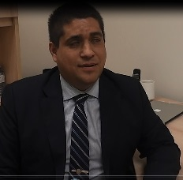
José Maria Viera, New CEO for the WBU

Our Finances

Please see our annual audited Financial Statements for 2017 for detailed information. In summary, we finished the year 2017 with an operating surplus of $17,952 USD. While this was a little less than budgeted, it was nevertheless quite satisfactory given that we had to write off unpaid membership fees from the last quadrennial period in the amount of $19,894 and we also lost two of our platinum level supporters. Overall, our unrestricted assets increased by $17,952 to $372,590. This represents the third consecutive year when we have operated within a small operating surplus and have been able to add to our unrestricted reserve level.

Our Key Supporters

Approximately 70% of our revenues came from members during this year. This proportion would have been much higher had it not been for the substantial contribution of the Open Society Institute Foundation (FOSI) for their support of our Marrakesh Ratification and Implementation campaign. In addition to the membership fees paid by all WBU members, many of our members contribute to support our work in cash and in kind. And while the cash contributions are extremely important to us and help sustain our operations, it is through the in-kind contributions of our members that enable Officers and committee members to attend meetings, take on projects and so forth. We are extremely grateful for that support.

The following lists voluntary monetary core sponsorship contributions from WBU members over and above their membership fees. These members have contributed throughout the four-year term:

Platinum Sponsors
CNIB (The Canadian National Institute for the Blind)
ONCE (Organización Nacional de Ciegos Españoles)
Sightsavers International
Vision Australia
Diamond Sponsors
SFB (Swiss Federation of the Blind and other partners)
NABP (Norwegian Association of the Blind and Partially Sighted)
Gold and Loyalty Sponsors
NIB (National Industries for the Blind, USA)
NAB (Danish Association of the Blind)
DBSV (Germany)
Other Major Contributors to Specific WBU Projects
CBM (Christian Blind Mission International)
Open Society Institute Foundation (Soros Foundation)

Conclusion

We do hope that this summary provides you with useful and interesting information about WBU’s work and achievements over the past year. We have set ourselves an ambitious plan to move towards our vision of a more inclusive community for full participation and while we fully understand that there is a great deal to be done to achieve this vision, it is critically important that we make measurable progress towards that goal.

We wish to express our appreciation to our WBU Officers, our Committee and Working Group Chairs as well as to all members of those committees and working groups for the important roles they play in helping us advance our work for the benefit of the 253 million blind and partially sighted people worldwide that we represent.

OUR WBU LEADERS 2017 – 2020

WBU Officers
Dr. Fredric Schroeder,
President
president@wbu.ngo

Mr. Fernando Riaño,
1st Vice President
friano@ilunion.com
Dr. Elly Macha (to March 2017)
Ms. Donatilla Kanimba (From September 2017)
2nd Vice President
donakanimba@gmail.com
Mr. A.K. Mittal
Secretary General
mittal24ak@gmail.com
Ms. Martine Abel-Williamson
Treasurer
martine.the1@xtra.co.nz
Mr. Arnt Holte
Immediate Past President
Arnt.Holte@blindeforbundet.no

REGIONAL PRESIDENTS
AFRICA (AFUB)
Mr. Yaw Ofori Debra
yawdebra2015@gmail.com

ASIA (ABU)
Mr. Santosh Kumar Rungta
nfbsec.g@gmail.com
ASIA PACIFIC (WBU-AP)
Ms. Michiko Tabata
tabacchi@par.odn.ne.jp

EUROPE (EBU)
Mr. Wolfgang Angermann
ebupresident@euroblind.org

LATIN AMERICA (ULAC)
Mr. Volmir Raimondi
presidencia@ulacdigital.org

NORTH AMERICA /CARIBBEAN (WBU-NA/C)
Mr. Charles Mossop
charles.mossop@cnib.ca

WBU STAFF
Dr. Penny Hartin,
Chief Executive Officer
penny.hartin@wbu.ngo
Mr. José Maria Viera (as of April 2018)
Jose.viera@wbu.ngo
Ms. Ianina Rodriguez, Administrative Assistant
ianina.rodriguez@wbu.ngo
Ms. Caitlin Reid (to July 2017)
Ms. Terry Mutuku,
Communications Officer
(As of August 2017)
Terry.mutuku@wbu.ngo
José Viera
Human Rights Policy Advisor (to April 2018)
Jose.viera@wbu.ngo
Ms. Florence Ndagire
Human Rights Policy Advisor (as of April 2018)
Florence.ndagire@wbu.ngo

Committee & Working Group Chairs
Marrakesh Treaty Ratification Campaign
Maryanne Diamond/ Scott LaBarre

Access to the Environment
Martine Abel-Williamson

Technology
Sachin Pavithran

Human Rights
S.K. Rungta

Employment
Angela Hartley

Development
A.K. Mittal

Women’s Network
Cathy Donaldson/ Donatilla Kanimba (as of February 2018)

Youth Network
Diane Bergeron

Elderly Persons Network
Charles Mossop

Low Vision Network
Penny Hartin
World Braille Council
Kevin Carey

Regional Sustainability
Volmir Raimondi

Disaster Risk Reduction
Michiko Tabata

Constitution
Wolfgang Angermann

Finance
Martine Abel-Williamson

Membership Fees
Martine Abel-Williamson

Nominations
Maryanne Diamond

Communications
Fernando Riaño

Resource Generation
Fernando Riaño

CRPD & SDG Committee work
Fernando Riaño and Lars Bosselmann

CONTACT US

World Blind Union
1929 Bayview Avenue
Toronto Ontario
Canada M4G 3E8
Tel: 1 416 486 9698
Fax: 1 416 486 8107
Email: info@wbu.ngo
Web: www.worldblindunion.org
www.wbu.ngo
Twitter: @Blindunion
Facebook: BlindUnion

