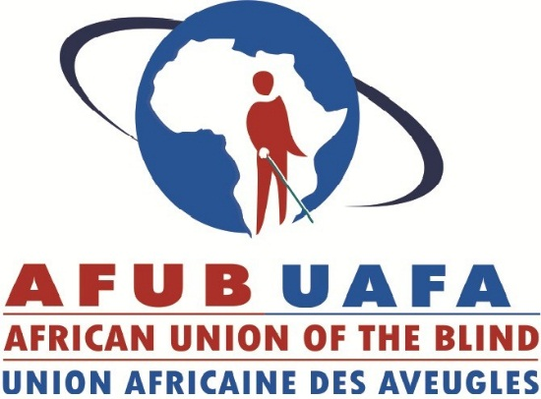
African Disability Protocol
African Disability Protocol
African Disability Protocol
African Disability Protocol
African Disability Protocol

African Disability Protocol
African Disability Protocol
African Disability Protocol
African Disability Protocol
African Disability Protocol

ANNUAL REPORT 2018

Prepared by
Dandy Mubima Ngandu
Fundraising & Communications Officer

Table of Contents

ACRONYMS 3
WORD FROM THE PRESIDENT 4
EXECUTIVE SUMMARY 5
1.0. ABOUT AFUB 6
2.0. VISION, MISSION & OBJECTIVES 7
3.0. HIGHLIGHTS OF THE YEAR 8
3.1. Advocacy 8
3.1.1. The Human Rights Project for the Visually Impaired in Africa 8
3.2. Membership Development 10
3.2.1. Strengthening of Portuguese and Spanish-speaking Member Organizations project 10
3.3. Organisational strengthening 11
3.3.1. Strengthening the Organisational Capacity of AFUB 11
4.0. OUR FINANCES 14
5.0. CHALLENGES & WAY FORWARD 15
5.1. Challenges 15
5.2. Way forward 15
6.0. CONCLUSION 16
7.0. AFUB BOARD OF OFFICERS 2016 - 2019 17

ACRONYMS

ACHPR: African Commission on Human and People’s Rights
ADP: Africa Disability Protocol
AFUB: African Union of the Blind
AU: African Union
DAB: Danish Association of the Blind
DPOs: Disabled People’s Organisations
GBU: Ghana Blind Union
NFVI: Namibian Federation of the Visually Impaired
NGO: Non-governmental Organisation
OAU: Organisation of African Unity
UNCRPD: United Nations Convention on the Rights of Persons with Disabilities
WBU: World Blind Union

WORD FROM THE PRESIDENT
Today, the African Union of the Blind (AFUB) is a leading voice in the blindness sector thanks to its team of dedicated personnel, membership and board of officers who work tirelessly towards the realisation of its vision of a continent where blind and partially sighted persons enjoy equal rights, social inclusion and full participation in development.

In 2018, more than 30 years since AFUB’s establishment, our collaboration with other disability actors coupled with our engagement with the African Union towards policies and practices that guarantee the rights and inclusion of blind and partially sighted persons in Africa at all levels, contributed to the adoption by the African Union Assembly of the Draft Protocol to the African Charter on Human and Peoples’ Rights on the Rights of Persons with Disabilities in Africa, referred to as the African Disability Protocol (ADP). We celebrate this exciting news.
Yet, we know that business as usual will not get us to the realisation of our mission. We still need a complete paradigm shift in the way the society views persons with disabilities in general and blind and partially sighted persons in particular.

During this year, we continued to work strategically to protect and promote the human, civil, political, economic, social and cultural rights of blind and partially sighted persons in Africa. We pursued our initiatives in advocacy and human rights, capacity building of Portuguese and Spanish speaking member countries of AFUB, and organisation strengthening in collaboration with our development partners.

We launched a campaign for the ratification of the ADP by African governments; this campaign kicked off in Kenya where AFUB has its headquarters. Member organisations in Ghana and Namibia continued to use the UN Convention on the Rights of Persons with Disabilities (UNCRPD) as a tool to carry out national advocacy. We carried out national workshops and seminars for our Lusophone and Spanish speaking members in Mozambique, Angola, Guinea Bissau, and Cape Verde which contributed to strengthening the members’ capacities to deliver on their national advocacy role as well as to undertake national initiatives towards the ratification and domestication of disability inclusive instruments.

In June of this year, AFUB held its 30th anniversary celebration to showcase its work; published a magazine of its history and launched a fund to ensure that delivery of its coordinative and advocacy roles in Africa continues on.

Our aim going forward is to reach many more blind and partially sighted persons in places where they need us most. Our work is cut out for us. With the current economic meltdown, it is becoming increasingly difficult to find new supporters for our work, but with hard work and dedication, we will recruit new supporters.

We thank our partners for walking this journey with us for the past 30 years and count on your continued support. We look forward to 2019 and what it brings.

Yaw Ofori Debra, AFUB president

EXECUTIVE SUMMARY
This report spans from January to December 2018, which constitutes the second year of implementation of the 2017- 2019 AFUB Strategic plan. 2018 is also the year preceding AFUB’s 9th General Assembly, which is scheduled to be held in late 2019. The current strategic plan operates on three key strategic pillars namely Advocacy, Membership Development and Organisational Strengthening.
In 2018, AFUB’s strategic objective remains to protect and promote the human, civil, political, economic, social and cultural rights of blind and partially sighted people in Africa.

This report begins by giving a brief recollection of who we are, our structure, what we do, our mission, vision and objectives.

The report goes on to give an overview of the projects/programs undertaken at the secretariat towards enhancing AFUB’s visibility and profile as well as realisation of AFUB’s strategic objectives. The report endeavours to highlight achievements under AFUB’s current projects namely, the Human rights Project for the Visually Impaired in Africa; project on Strengthening of Portuguese and Spanish-speaking Member Organizations; Strengthening the organisational capacity of AFUB.

AFUB was able to continue implementing its activities and projects though with a considerably reduced resource base, and this report also gives a highlight of our finances, mentioning the sources of revenue as well as the use of funds.

The year 2018 has not been without its own share of challenges. AFUB Executive Director and Honorary Treasurer resigned with effect from July, and an interim Executive Director was appointed to oversee the work of the secretariat and ensure that AFUB’s objectives for the period are realised.

The meagre resource base, challenges in communication flow, high staff turn-over marked especially by the resignation of the Executive, among others constitute drawbacks to the implementation of AFUB’s work, challenges that could not have been met without the support of partners, staff, members and friends of AFUB.

AFUB acknowledges and appreciates the financial and technical support from its development partners, the membership and other stakeholders, which made it possible for the successful rolling out its activities during 2018.

In conclusion, the report highlights lessons learnt in the process of pursuing our mission and objectives, as well future plans to strengthen AFUB’s sustainability to continue delivering on its advocacy and coordinative roles.

1.0. ABOUT AFUB

The African Union of the Blind (AFUB) is a continental non-governmental organisation (NGO) of national organisations/ associations of blind and partially sighted persons in Africa. AFUB was established in October 1987, in Tunis, Tunisia, under the auspices of the Organisation of African Unity (OAU), now African Union (AU). AFUB’s founding Assembly registered a total of 23 members.

AFUB represents the collective voice for blind and partially sighted persons and a regional umbrella for the World Blind Union (WBU).
The African Union of the Blind (AFUB) enjoys observer status in the African Union under Resolution CM/Res.944 (XL) and holds a semi consular status in Kenya.

Currently the numerical strength of AFUB’s membership stands at 53 African countries.

The membership of the African Union of the Blind is currently organised into five regions namely, Central Africa, East Africa, North Africa, Southern Africa and West Africa. Other members include international members and honorary life members.
Each region has a regional assembly that meets at least six months before the Union’s general assembly.

A General Assembly consisting of delegates from the member organisations, the members of the outgoing board, international and honorary life members and observers meets every four years to review the policies and progress of the Union.

An eight-member Board of Officers meets regularly to transact business on behalf of the General Assembly. These consist of 5 regional representatives and the chairperson of the women’s committee, an Honorary Treasurer, and the Executive Director who serves as an ex-officio secretary to the Board.

A Table of Officers consisting of the President, Vice President and the Executive Director meets and consults regularly to review progress in implementing the policies of the Board and to make executive decisions.

A Secretariat headed by the Executive Director implements the policies and programs of the union.

VISION, MISSION & OBJECTIVES

VISION
A continent where blind and partially sighted persons enjoy equal rights, social inclusion and full participation in development

MISSION
To strengthen member organisations and create unity of purpose among them through capacity building and advocacy in partnership with governments, international agencies and other stakeholders

OBJECTIVES
- To promote the human, civil, political, economic, social and cultural rights of blind and partially sighted people in Africa;

- To strengthen national associations of the blind to enable them to promote the rights of blind people within their countries; and

- To strengthen the self-awareness of blind and partially sighted persons, to develop their personality, self-respect and sense of responsibility

HIGHLIGHTS OF THE YEAR

2018 is the second last year of implementation of AFUB’s 2017 – 2019 strategic plan. The Union’s annual plans are derived from this three-year strategy, whose focus is three major strategic pillars; thus:
Advocacy towards policies and practices that guarantee the rights and promote inclusion of blind and partially sighted persons at national, regional and international levels; Membership strengthening; and, Organizational development.

The focus in 2018 was therefore on the following specific objectives:

- Increase our engagement with the African Union to prioritize issues of blind and partially sighted persons in the agenda of African governments
- Increase our involvement with regional, bilateral, international and corporate agencies for more inclusive developmental policies for blind and partially sighted persons in Africa
- Build the capacity of national member organisations to effectively use the CRPD as a tool to advocate for inclusive implementation of Sustainable Development Goals, (SDGs) in their countries.
- Strengthen our governance and management systems for improved coordination and oversight of the organisation’s activities.
- Increase the development, mobilisation and management of our resources towards financial sustainability.
- Enhance our information management, communication and public relations in order to improve on our heritage, visibility and profile

3.1. Advocacy

3.1.1. The Human Rights Project for the Visually Impaired in Africa

The Human Rights project for the visually impaired in Africa aims at addressing the denial of human rights of blind and partially sighted persons in Africa and systematically advocating for equal rights and opportunities for Persons with Visual Impairment. The project has a special focus on Ghana in West Africa and Namibia in Southern Africa. The objective of the project is to contribute to the consciousness of human rights of the visually impaired persons by improving the capacity of AFUB, Ghana Blind Union (GBU) and Namibian Federation of the Visually Impaired (NFVI) to promote human rights and equal opportunities of Blind and partially sighted persons in Africa using the UN Convention on the Rights of Persons with Disabilities (CRPD) as an advocacy tool. The project therefore focuses on equal rights, access to education, work and employment using the UNCRPD’s Articles 5, 24 and 27 respectively. The year 2018 marked the beginning of a new phase of the project (2018 – 2021).

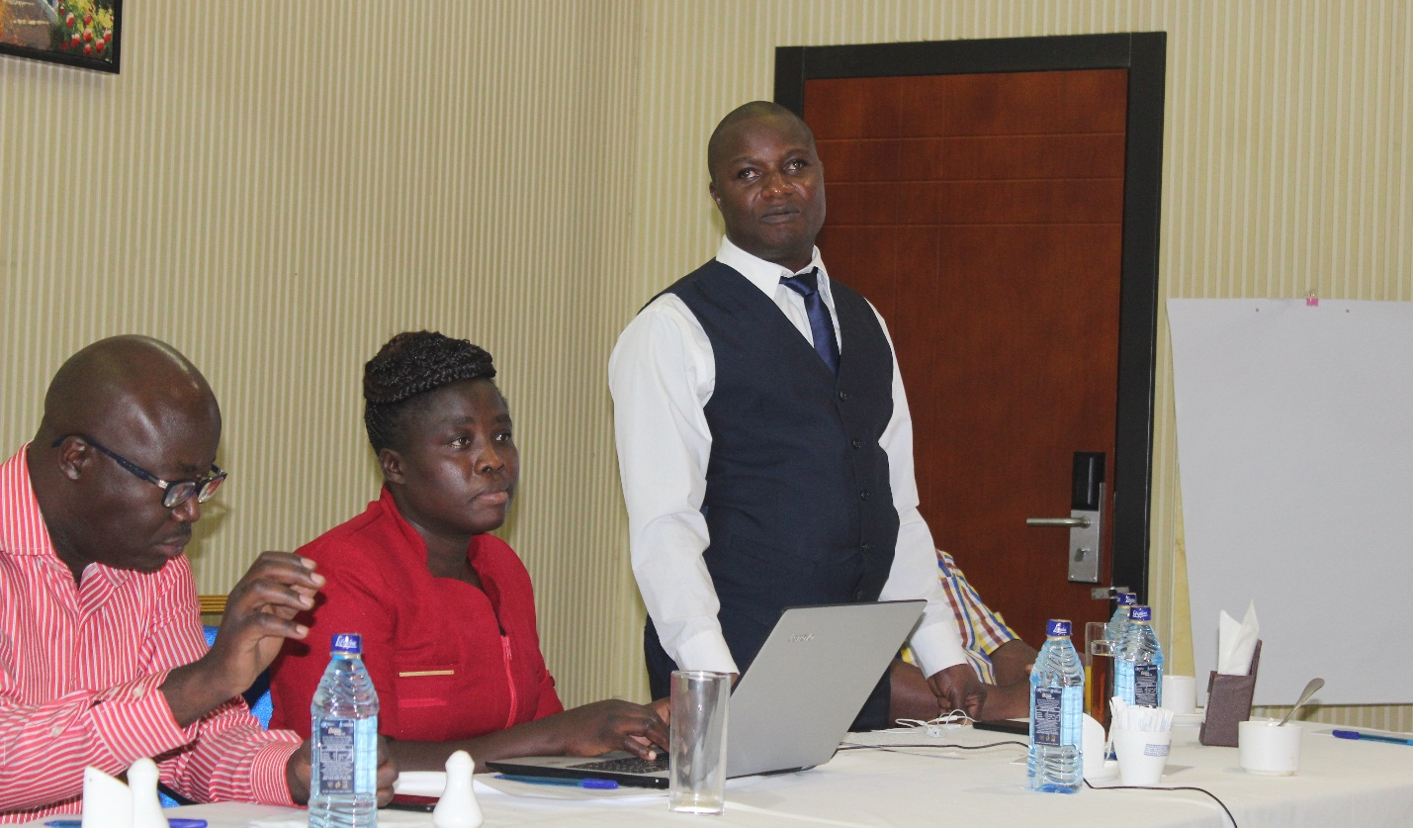
AFUB Program Officer for Human Rights and Advocacy (standing) presenting during a breakfast meeting in Nairobi

In line with its strategic objective to advocate for policies and practices that guarantee the rights and promote inclusion of blind and partially sighted persons at national and international levels; AFUB managed to submit two position papers on the African Disability Protocol (ADP) on the Rights of Persons with Disabilities to the African Commission on Human and Peoples’ Rights (ACHPR) in April and October, 2018 at the 62nd and 63 ordinary sessions of the ACHPR in Mauritania and The Gambia respectively.
In May, AFUB participated in the Community Based Rehabilitation Africa conference network CBR under the theme ‘CBR for resilience building and sustainable development: leave no one behind’, was aimed at influencing stakeholders’ actions of the participating countries in ensuring disability issues are integrated in the development agenda. AFUB’s participation in the conference contributed to increase its visibility as AFUB was able to talk about its mission, vision and work.
In August, the AFUB Women’s Committee benefited from a training held in Nairobi, Kenya, on the UNCRPD, Marrakesh Treaty, African Disability Protocol and other human rights instruments; this with the aim of empowering them and strengthening their capacity to use these tools for national advocacy as well as equip blind and partially sighted persons in their countries to be self-advocates.

In November AFUB organised a meeting with diplomats and various disability actors and stakeholders in Nairobi, Kenya to create awareness on the ADP but also to push the campaign for ratification of this protocol. AFUB has its headquarters in Kenya and is working towards getting Kenya to ratify the protocol, therefore setting the pace for other African countries.
AFUB had the opportunity still in November of 2018 to participate in the National Congress, training on leadership and good governance of NFVI and development of their five-year strategic plan. This was in line with AFUB’s objective of strengthening the management and operational capacity of its member organisations to effectively deliver on their programs.

In December, MyRight carried out an organisation capacity assessment of AFUB. This exercise together with the recommendations are geared towards strengthening structures and systems for improved programming at AFUB. To further the same objective, AFUB staff underwent a training in project management and developed a monitoring and evaluation tool to further enhance its program work.

In order to strengthen the working relationship between the main players in the project, AFUB, GBU and NFVI held a partnership meeting to share experiences and lessons learnt. A report on this was shared with SRF and MyRight.

3.2. Membership Development

3.2.1. Strengthening of Portuguese and Spanish-speaking Member Organizations project

Since 2011, AFUB has been in partnership with the Norwegian Association of the Blind and Partially Sighted, NABP towards the achievement of AFUB’s objective of establishing, strengthening and developing national associations of the blind and partially sighted persons. The overall goal of this partnership is to strengthen the Portuguese and Spanish speaking member organisations of AFUB to enable them improve their advocacy work towards influencing their national governments and become more active members and representatives of AFUB. This is to be achieved through workshops, seminars, trainings and meetings in the target countries of Angola, Cape Verde, Equatorial Guinea, Guinea Bissau, Mozambique and Sao Tome & Principe.

A country based training workshop for women and youth of ACAMO Mozambique was held in May 2018. This workshop was aimed at getting the women and youth to understand the importance of developing action plans for delivery of their work, gathering information to assist them in coming up with their action plans; and also offering them an opportunity to clearly define their strategic priorities for the next five years. The workshop is in line with AFUB’s strategic objective of working with national member organizations to strengthen their governance, management and operational capacity to effectively deliver on their programs.
In September, in Luanda, Angola AFUB held a Knowledge and Exchange Workshop on the UN Convention on the Rights of Persons with Disabilities (CRPD), Marrakesh Treaty and African Disability Protocol (ADP). The aim of the workshop was to increase the general awareness on the Convention on the Rights of Persons with Disabilities among the participating Disabled People’s Organisations (DPOs) and the general public; share experiences in relation to the process of signing and ratifying the UNCRPD; develop contacts and networks between the participating DPOs; develop effective advocacy strategies towards governments on the basis of best practices; consolidate AFUB’s position as a central and relevant DPO on the UNCRPD in Africa. Recommendations that ensued from the workshop were dissemination of information on the CRPD, ADP and Marrakesh Treaty; strengthen abilities and skills for lobbying and advocacy work; document best practices and lessons learned for replication across the Portuguese and Spanish speaking member organizations to support ratification of African Disability Protocol, Marrakesh Treaty and CRPD through AFUB technical support. This workshop is an effort towards AFUB’s strategic objective to build the capacity of members to undertake national initiatives towards ratification and domestication of the CRPD, Marrakesh treaty, Africa disability protocol, and other continental instruments.
In October, the organisation of the blind in Guinea Bissau benefited from the same training workshop as the Luanda one with the same goal.
This project also funded the participation of the project officer to participate in the 62nd and 63rd ordinary sessions of the (ACHPR) in April and October in Mauritania and Gambia respectively.
In mid-December, Mr. Terje from NABP visited AFUB offices to carry out due diligence on the organisation.

3.3. Organisational strengthening

3.3.1. Strengthening the Organisational Capacity of AFUB

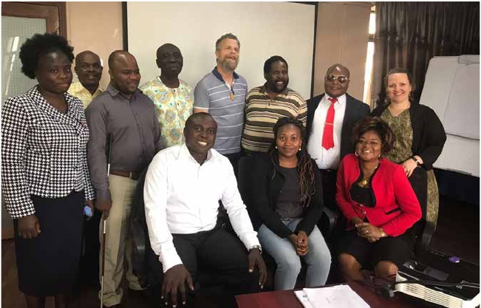

AFUB Board of officers, staff and DAB partners during the learning workshop held in May
The partnership between AFUB and DAB dates to over twenty years ago, and has blossomed over the years from support for conferences, meetings and assemblies to support for specific projects from Danish as well as DAB funding.
In 2016, AFUB secured funding from Disabled People’s Organisations – Denmark (DPOD) through the Danish Association of the Blind (DAB) towards strengthening the organisational capacity of AFUB. Since AFUB was not able to fully implement its 2013-2016; this funding would be geared towards strengthening governance and management systems for improved coordination and oversight of the organisation’s activities; improving on the mobilisation and management of resources towards financial sustainability; enhancing information management, communication and public relations in order to improve on heritage, visibility and profile.
In the first phase of the project, AFUB put in place a cost effective Skype for credit communication system to improve flow of communication between board and secretariat but also between the secretariat and the membership. A Communication policy to provide a framework for good communication within the work environment of AFUB and a Resource Mobilisation Strategy to initiate a structured approach to accessing additional income to enable its governance, programmatic, financial and administrative operations continue were developed with support from this project.
AFUB also put in place and operationalized an archiving system to store information and institutional memory and not have them stored on a particular individual’s computer.
In April 2018, this initiative entered into its second six months phase. This second phase was aimed at building on the results achieved in the first phase.
In May, a learning workshop was held in Nairobi, Kenya with two partners from DAB present as well as some AFUB board and staff members. This workshop was aimed at having a joint reflection on partnerships, what are the key elements in developing and sustaining a partnership, what have we (AFUB/DAB) obtained in the partnership, how this can be sustained, and which areas AFUB needs to pay specific attention to in the near future.
The partnership between DAB and AFUB was redefined to take on a more technical assistance nature, with DAB offering technical assistance and advice to AFUB on strategy, policy, and grant making, but not direct funding. Possibly a co-funding role in a multilateral project, with a specific role to play and with other external funders.
With currently diminishing resources, AFUB requires to dedicate much more effort towards resource mobilisation and the board can support the secretariat by introducing potential donors.
A six month priority plan (June to December 2018) to assist AFUB in fundraising and would focus on increasing funds, improving membership communication, improving partner communication and functioning documentation and monitoring system in AFUB. (Detailed plan is available)
A great challenge to AFUB over the years has been flow of communication within the different arms of the Union (Board, secretariat and members. Despite the communication strategy in place, there is no clear plan for how, what and when each function should communicate. The learning workshop also embarked on developing a communication plan for AFUB to complement communication policy.
In June, AFUB held its 30th anniversary celebrations. These celebrations marked 30 years since the creation of the Union, and AFUB was able to publish its 30 year history and share with partners present. AFUB also launched a fund that it intends to grow over the next five years; this fund will help ensure that AFUB’s work is supported to go on reaching blind persons in the continent.
At the celebrations, AFUB was also able to collect some funds to start up the fund.
In order to better guide the AFUB board’s oversight role on the organisation, the project supported the development of a Board Manual outlining the roles and responsibilities of the board. The manual. The manual was finalised by AFUB board and adopted in August as a working document.
An important link between the secretariat and the membership is the AFUB Regional representatives. Communication flow between the secretariat and the membership being a challenge, the regional representatives were facilitated to communicate with their regional members and produced reports on the activities in their regions; once received, these reports were used by the secretariat for documentation, and fundraising.
Using the Skype for credit system, quarterly board meetings were held according to the board’s resolution on meetings; these meetings were used to update the board on the status of the project on strengthening the organisational capacity of AFUB, as well as other operational issues.

The staff benefited from a training in project cycle management, monitoring and evaluation, and report writing in May during the learning workshop and in August, aimed at strengthening resource mobilisation efforts. As a result of the workshop, the staff with the help of an external consultant developed a Monitoring and evaluation framework for AFUB to improve programming at AFUB towards result oriented programming and reporting. Reporting templates to facilitate reporting on project work, for improved programming at AFUB, were also developed. The Monitoring and Evaluation framework will be adopted at the next AFUB board meeting, but the staff are currently using the reporting templates that were developed to report on the progress in the projects.

This project also supported AFUB to showcase its work. For the first time in several years, AFUB was able to participate in regional meetings and hold exhibitions to showcase its work. At the Global Disability Summit held in London, UK in July, the Special Needs Education Conference held in Johannesburg South Africa in August and the NGO Forum held in Banjul, the Gambia in October AFUB showcased its work offering an opportunity to network and meet new partners, which AFUB did and has strengthened its collaboration with the Ministry of Foreign Affairs, and the Ministry of Labour and Social Protection of the Republic of Kenya. These are key ministries for advocacy for the cause of persons with disabilities in Kenya.

Through delivery of this project AFUB has strengthened its governance, management, communication and resource mobilisation systems by adopting policies as well as putting systems and structures in place to sustain the organisation. AFUB needs to follow up and build on these results by updating policies and reviewing systems and structures for a more sustainable AFUB moving forward.

- OUR FINANCES
The following is a summary of our financial position for 2018. Our audited financial statements offer more detailed information.

Sources of Revenue

Use of Funds
Grants 93.4% Administration 43.8%
Other revenue 4.9% Program costs 40.4%
Membership fees 1.7% Organisational Development 10.4%
Governance costs 4%
Research, Monitoring & Development 0.8%
Capital Costs 0.4%
Membership 0.1%

Over 90% of our funding comes from grants from development partners and these are used both to run programs as well cater for administration, governance and organisational development costs among others.
We thank all development partners and organisations who support AFUB’s work. We encourage our membership to continue paying their membership fees, as it contributes revenue for the Union to keep running. Indeed AFUB would not be able to do what it does without the support of our members, partners and friends.

- CHALLENGES & WAY FORWARD

5.1. Challenges

- AFUB’s resources are meagre compared to its continental mandate and it therefore becomes difficult to effectively deliver on its critical roles like facilitating the board in playing its governance and oversight role; ensure communication flow between different arms of the organisation, carrying out extensive advocacy work among others as outlined in the organisation’s strategy.

- Meeting the cost of administrative overheads remains a challenge for the organisation

- AFUB board of officers and regional representatives are curtailed in their operations due to limited or no funding to enable them communicate and/or monitor the countries they represent.

- Our thinly staffed Secretariat witnessed the resignation of the Executive Director in the month of July. This created some backlog and overload as Secretariat adjusted to the new challenge posed by the Executive Director’s departure.

- Getting feedback from some of our member organisations is really slow, sometimes totally lacking as most of them have temporary email addresses which are mainly individual, seasonal and not institutional. This causes delays in the secretariat receiving project progress reports to be shared with donors

5.2. Way forward

- AFUB needs to find means and ways of diversifying its sources of revenue and attract more unrestricted revenue to help cover its administrative overheads. For example, AFUB could explore investing part of its reserves to attract some revenue, even as the secretariat supported by the board continue in fundraising efforts to expand AFUB’s donor base

- To effectively deliver on their governance role, ensure communication flow and adequate monitoring of member countries in their respective regions, the regional representatives need to be facilitated with some communication allowance, but this needs to be results driven with stringent monitoring and accountability mechanisms in place

- AFUB will have to ensure that the Skype for credit system is operational at all times to ensure smooth communication with members and board of officers, and using where possible, new internet media, to maintain communication with internal and external public; for example a Whatsapp group was created for the board of officer and this could be extended to member organisations

- CONCLUSION

AFUB has had its fair share of challenges in 2018 marked by steadily diminishing resources hampering full implementation of its work, as well as administrative changes with the resignation of the Executive Director and the Honorary Treasurer.
Despite these setbacks, AFUB’s advocacy and capacity building work continued even though not as anticipated due to restriction in resources. Nevertheless, impact was felt all the same with the adoption of the African Disability Protocol and many more African countries ratifying the Marrakesh Treaty.
The advocacy and organisational capacity of member organisations in several AFUB member countries was strengthened through our programs, so that women and youth participation in organisational leadership are given due recognition.
This could not have been achieved without the support of AFUB’s membership, board of officers, staff, development partners, and friends. We acknowledge your support and thank you for your contribution to the advancement of our work; we count on your continued support in our post 30 years journey.
2019, here we come!!!

- AFUB BOARD OF OFFICERS 2016 - 2019

Mr. Yaw Ofori Debra – Ghana
AFUB President &
West Africa Regional Officer
yawdebra2015@gmail.com

Ms. Eveline Angomwi
AFUB Vice President &
Chairperson of AFUB Women’s Committee
Association Nationale des Aveugles du Cameroon (ANAC)
Email: evelineangonwi@gmail.com

Mr. Louis Benedicto Cyprian
East Africa Regional Representative
Tanzania League of the Blind (TLB)
louisbenedicto16@gmail.com / tanleb@yahoo.co.uk

Mr. Ishumael Zhou
Southern Africa Regional Representative Zimbabwe National League of the Blind (ZNLB)
zimnationalleague@gmail.com
ishumaelzhou@gmail.com

Mr. Mohamed Ezzaoui
North Africa Regional Representative
Organisation Alaouite pour la Promotion des Aveugles au Maroc (O.A.P.A.M)
md.ezzaoui@gmail.com

Mr. Paul Tezanou - Cameroon
Central Africa Regional Representative
Association Nationale des Aveugles du Cameroun
ptezanou@yahoo.fr

