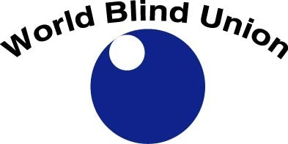

WBU E-BULLETIN
VOLUME 15, ISSUE 1
January 2019

Contact us at:

World Blind Union
1929 Bayview Avenue
Toronto, Ontario, Canada
M4G 3E8

Telephone: 1-416-486-9698
Fax: 1-416-486-8107
Email: info@wbu.ngo
Website: www.wbu.ngo
Twitter: @BlindUnion
Facebook: www.facebook.com/BlindUnion

Changing What It Means to be Blind!

CONTRIBUTIONS TO THE E-BULLETIN 4
PRESIDENT’S MESSAGE 4
WBU NEWS 6
UNITED NATIONS ADOPTS WORLD BRAILLE DAY RESOLUTION 6
WBU BRAILLE LITERACY SCHOLARSHIPS 7
WBU TREASURER WINS LEADERSHIP AWARDS 11
UPDATES FROM THE REGIONS 12
EBU REPORT ON BRAILLE TEACHING AND LITERACY 12
WBU-ASIA PACIFIC WOMEN'S FORUM HELD IN MONGOLIA 12
UNDP ORGANIZES SEMINAR ON MARRAKESH TREATY IN VIET NAM 13
POLITICAL PARTICIPATION OF PEOPLE WITH DISABILITIES PROJECT IN SENEGAL 14
ULAC LAUNCHES A NEW MAGAZINE “LATIN AMERICA” 15
UPDATES FROM GLOBAL PARTNERS 16
WBU COLLABORATES WITH INTERNATIONAL PARTNERS TO PROMOTE SMART CITIES AND SDGS 16
WBU JOINS CITIES FOR ALL GLOBAL CAMPAIGN 16
WBU, ICEVI AND ONCE SIGN A COLLABORATION AGREEMENT TO ORGANISE GENERAL ASSEMBLY IN 2020 17
WBU AND CBM SWITZERLAND DISCUSS FUTURE COLLABORATION 18
INTERNATIONAL COUNCIL FOR EDUCATION OF PEOPLE WITH VISUAL IMPAIRMENT MESSAGE FOR WORLD BRAILLE DAY 18
NORWEGIAN ASSOCIATION OF THE BLIND HANDS OVER WISHES TO GOVERNMENT 19
SWEDISH ASSOCIATION OF THE VISUALLY IMPAIRED DEMAND POLITICAL RIGHTS 20
DANISH ASSOCIATION OF THE BLIND EMPHASIZES IMPORTANCE OF BRAILLE 20
SUBMISSIONS FOR THE LIGHTHOUSE’S ANNUAL $25,000 PRIZE ARE OPEN 21
DOLPHIN COMPUTER ACCESS ANNOUNCES FREE EASYREADER APP FOR TALKING BOOKS 22
FIRST WORLDWIDE SURVEY OF AUDIO DESCRIPTION ACTIVITY CONDUCTED 22
WBU PARTICIPATE AT UN WORLD DATA FORUM 23
320,000 TITLES AVAILABLE FOR CROSS-BORDER EXCHANGE IN EU 23
FEATURES 23
MEET AMBA SALELKAR, A YOUNG LAWYER AND DISABILITY ACTIVIST BASED IN CHENNAI, INDIA​ 23
RESOURCES 27
IMPLEMENTING THE MARRAKESH TREATY - A PRACTICAL GUIDE FOR LIBRARIANS 27
PROJECT ASPIRO 28
SUCCESS STORIES ON EMPLOYMENT 28
UPCOMING EVENTS 28
WORLD READ ALOUD DAY 28
REMINDER: CONTACT INFORMATION 29
PICTORIAL NEWS 29
LETTERS TO THE EDITOR 30
THE WBU REGIONS 30
AFRICA 31
ASIA 31
ASIA-PACIFIC 31
EUROPE 31
LATIN AMERICA 31
NORTH AMERICA/THE CARIBBEAN 31
WBU TABLE OFFICERS 31
REGIONAL PRESIDENTS 31
WBU STAFF 32
OUR SPONSORS 32

CONTRIBUTIONS TO THE E-BULLETIN
We welcome articles from the regions and from members who wish to share their good news with the rest of the world. Our next deadline for content is April 2nd, 2019. We accept submissions in English, French, and Spanish in electronic format. Please note that we retain the right to edit submissions due to space limitations. Send your news to: Terry.Mutuku@wbu.ngo

PRESIDENT’S MESSAGE

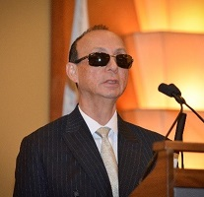

Dear members of the World Blind Union,

One of the crowning achievements of the World Blind Union is the Marrakesh Treaty to Facilitate Access to Published Works for Persons Who Are Blind, Visually Impaired or Otherwise Print Disabled. It is now in force, and we continue to work toward all nations ratifying the Treaty. The Treaty is foundational to literacy, but it will not solve the literacy crisis alone.

As you know, parallel to our Treaty work was leading the effort to develop a low cost refreshable braille notetaker, the Orbit Reader 20. As with the Marrakesh Treaty, the Orbit Reader 20 is a vital part of opening the door to literacy for the world’s blind and partially sighted people; however, it, too, is not the entire solution. Expanding opportunities requires public acceptance and support.
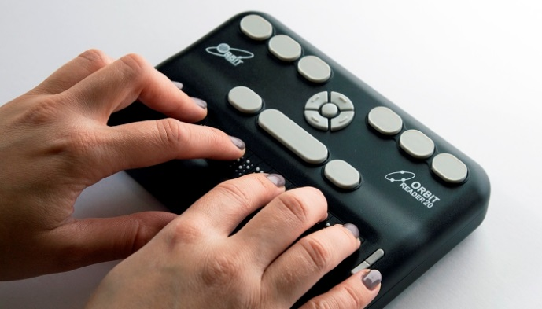
Orbit Reader 20 (Photo courtesy of RNIB)

Through the tireless efforts of Dr. Aubrey Webson, UN Ambassador for Antigua and Barbuda, on December 17th, 2018, the United Nations officially established January 4 as World Braille Day. World Braille Day brings attention to the right and ability of blind and partially sighted children and adults to live productive integrated lives. Supported by the Marrakesh Treaty and the Orbit Reader 20, World Braille Day stands as a call for social justice for blind and partially sighted people everywhere.

Now, it is up to us. We must use World Braille Day as an opportunity to focus the attention of governments, schools and the public on the need to expand access to literacy for blind and partially sighted children. With a foundation of true literacy, blind and partially sighted children can learn as others and grow up able to take their place as productive members of society.

Each day, each month, each year, together we move closer to full and equal opportunity. The challenges remaining before us are daunting, but, no matter the difficulty, together we have and will continue to change what it means to be blind.

Thank you for all you do.

Dr. Fredric K. Schroeder, President, WBU
(Watch a video message from the WBU President following the UN recognition of the World Braille Day: https://www.youtube.com/watch?v=uWwwLjBiG80&t=6s

WBU NEWS

UNITED NATIONS ADOPTS WORLD BRAILLE DAY RESOLUTION

On 17 December 2018, the United Nations General Assembly passed a WBU Resolution recognising World Braille Day, January 4th, as an international day to raise awareness of the importance of Braille​. The Resolution recalls that Braille is a means of communication for blind persons, as reflected in article 2 of the Convention on the Rights of Persons with Disabilities, and can be relevant in the contexts of education, freedom of expression and opinion, and access to information and written communication, as well as in the context of social inclusion for blind persons, as reflected in articles 21 and 24 of the Convention.

The Resolution affirms that the use of Braille by individuals who are blind or partially sighted ensures the communication of important information to them and others and represents competency, independence and equality. It recognizes that promoting human rights and fundamental freedoms in the context of access to written language is a critical prerequisite to the full realization of human rights for blind and partially sighted people

The UN proclaim 4 January as World Braille Day, to be observed each year, in order to raise awareness of the importance of Braille as a means of communication in the full realization of the human rights for blind and partially sighted people; and invites all Member States, relevant organizations of the United Nations system, other international organizations and civil society, including non-governmental organizations and the private sector, to observe World Braille Day in an appropriate manner, in order to raise public awareness of Braille as a means of communication.

The full Resolution is now available, in various languages, on the UN website and WBU website. We encourage members to download the Resolution and use it to promote Braille literacy in their countries.

Braille is used for all European-based languages and has also been adapted to present Arabic, and Asian languages as well. According to the most recent version of “World Braille Usage, Third Edition” (2013), braille is currently being used in more than 140 countries.

The World Blind Union believes that reading is a human right and that braille is critical and must be accessible worldwide. To commemorate the first official UN World Braille Day on January 4th, 2019, the WBU released a statement encouraging members, partners and the general public to continue advocating for braille literacy especially in developing countries where braille is inaccessible and expensive for most blind persons. In the statement, WBU called on governments to fulfill obligations stipulated under the UNCRPD and the Marrakesh Treaty by implementing policy frameworks that ensure promotion of braille literacy in their countries. The WBU emphasized that it is critical to produce print works in braille in order to provide the blind with access to the same reading and learning opportunities as the sighted.
The full statement is available on the WBU website: http://www.worldblindunion.org/English/news/Pages/WBU-statement-on-the-World-Braille-Day-2019.aspx

Members and partners of the WBU around the world celebrated the World Braille Day recognition with excitement. WBU's President, Dr. Fred Schroeder, attended the

UN General Assembly at the UN Headquarters in New York City where the resolution was approved and shared a thank you message via WBU's YouTube channel: https://www.youtube.com/watch?time_continue=29&v=uWwwLjBiG80 WBU members and global partners also shared their messages via Twitter, Facebook and YouTube.

The WBU thanks all those who shared their remarks and urges all to continue advocating and promoting braille literacy.

WBU BRAILLE LITERACY SCHOLARSHIPS
The World Blind Union is pleased to invite eligible candidates to apply for braille literacy scholarships. Preference is given to blind and partially sighted applicants from low income countries.

Applicants for all scholarships require a letter of application outlining how the scholarship will be used including a high level budget and a 500-word essay describing the course of study, program or self-employment project.

A support letter from a recognized organization of or for the blind within the country where applicant resides or a World Blind Union representative is also required.

All completed applications should now be submitted to the World Blind Union either electronically to info@wbu.ngo or mailed in Braille or print to WBU, 1929 Bayview Avenue, Toronto, Ontario, M4G 3E8. Canada. Applications are accepted at any time and scholarships are awarded prior to June 30 of each year.

The scholarships programmes include:

- The Hermoine Grant Calhoun Scholarship: This scholarship is offered to blind and partially sighted women attending college or university courses in any field of study within their own country. Women from least developed countries and low middle-income countries will be given priority. All scholarships will be for at least $100 USD or a maximum of US$750 is granted for any one course.

- The Pedro Zurita Youth Fund: This scholarship is for blind and partially sighted young men and women aged 15 to 30 years old. The scholarship is available for courses of study or programs with a duration of more than one year, but funding is not guaranteed for the full period of the course of study.

- The Barbara Marjeram Braille Literacy Scholarship: Applicants for this scholarship must be blind and partially sighted girls or women between the ages of 14 to 30 years. They must be enrolled in a recognized educational program in their own country. Applications are also accepted from students enrolled in a recognized distance learning program. They are expected to possess Braille reading and writing skills or be willing to pursue a course to learn Braille either on location or through an approved distance learning program. Applications must be accompanied by a 500-word essay describing the proposed course of study or program.

- The Gerald Dirks Scholarship for the Advancement of Braille Literacy is available for blind and partially sighted men and women aged 18 to 35 years old from Africa that work with Braille. Applicants are expected to possess Braille reading and writing skills. Preference will be given to candidates who have pre-requisite education or training to qualify either as a teacher of blind pupils; or train as a teaching assistant working alongside a qualified teacher in the classroom; or be involved in a creative Braille literacy project.

- The Mary Hochhausen Prize For Music And Literacy scholarship established in 2014 by the Hochhausen family to honour the memory of Mary Hochhausen is directed to young blind women and men between the ages of 18 – 35 years who have a specific interest in and demonstrated talent for music living in a developing country. Preference will be given to candidates living in the African Union.

Two or more prizes may be awarded in any one year up to a value of $2000 US each related to learning braille/braille music notation. Funds are also available for creating a school music program or similar project. Applicants for this scholarship are expected to possess Braille reading and writing skills; and have a demonstrated musical talent with an interest to further their education and/or work toward a career in music.
More information about these scholarships and application forms are available on our Scholarships promotion webpage.
WBU SCHOLARSHIPS BENEFICIARIES TELL THEIR STORIES
Noah Nartey, B.A Psychology student from Ghana

My name is Noah Nartey. I come from Krobo – Odumasi, Ghana. I am a B.A Psychology student at the University of Ghana. My sight impairment started in July 2011. Ever since then, I experienced a decline in my vision. A visual test conducted on me revealed that some part of my eye was damaged. In 2013, I was diagnosed with glaucoma and since then, I use eye drops to help reduce pressure and prevent my sight from further deterioration.
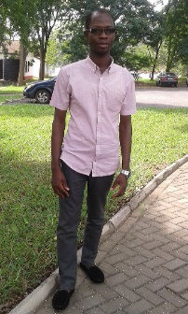 As a student, I find it difficult to see from the projected screens during lectures hence I rely on my colleagues to write some notes for me. Also, reading books with small font sizes is very difficult especially during vacation since I don’t have any assistive technology at home.
In addition, education is very expensive in Ghana. Buying books, payment of academic and residential fees, notwithstanding food and other basics make education expensive. And in my case having to use medications continuously creates further financial burden to my family.

The WBU scholarship will enable me to pursue my education. I am committed to acquiring knowledge and skills that can help me live independently and contribute positively to my society.
Marcelline Gato Nzamwitakuze, journalism and communication student, University of Rwanda

My name is Marcelline Gato Nzamwitakuze, a 24 years old student of journalism and communication at the University of Rwanda. I am visually impaired, I use braille for reading and writing, jaws for computer's use and a White Cane to walk around.
The WBU scholarship is very important to me because it is going to help me acquire braille reading materials and cover other school expenses. My dream is to become a professional journalist and advocate for problems facing people with disabilities. Also, being the only educated person among my siblings, I want to improve living conditions of my family and contribute better to my organization; the Rwanda Union of the Blind which advocates for the rights of the blind and partially sighted persons.
My advice to other people with a disability is not to be discouraged by barriers or problems that we face every day. Keep on rising, show what you can do and seek the support you need. I thank the WBU for choosing me to get this scholarship. It is a big chance for me. I will use it properly to make a positive impact on my life through studies.

WBU TREASURER WINS LEADERSHIP AWARDS
The World Blind Union is delighted to congratulate Ms. Martine Abel-Williamson, the WBU Treasurer, for winning two awards: The Supreme Award and the Making A Difference Award at the 2018 Attitude Awards ceremony in New Zealand.
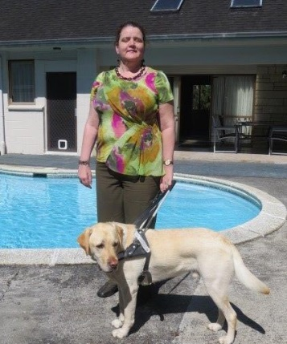 Ms. Martine Abel-Williamson, the WBU Treasurer
The Attitude Awards, now in their 11th year, are New Zealand's only national televised event celebrating the achievements of New Zealanders living with disabilities. The awards are run by a charitable trust which seeks to increase awareness of the benefits of the integration of people with disabilities into every aspect of political, social, economic and cultural life. The trust also runs Attitude TV which has a weekly television programme that talks about the lives of people living with disabilities and chronic health conditions.

Ms. Abel-Williamson is an advocate, lecturer and policy advisor for New Zealand's disability sector. Her achievements include being treasurer of the WBU, chair of the Auckland Disability Law Centre, vice president of Blind Citizens New Zealand and lead of the Asia-Pacific Regional UN Advocacy Network. She is also an advocate for safe environment and safe shared spaces.

Last year, she received a Queen's Service Medal for her services to people with disabilities. Read more about Ms. Martine Abel-Williamson on the WBU website.

Source: East Wind No. 27 December 2018 - the Official Newsletter of the World Blind Union – Asia Pacific (WBUAP) region (http://wbuap.org/archives/category/publications/east-wind)

UPDATES FROM THE REGIONS

EBU REPORT ON BRAILLE TEACHING AND LITERACY
Over 2016 and 2017, a European Blind Union expert group looked into the importance of Braille literacy and current barriers (technical, financial, psychological, etc.) to its development, in particular for young persons. The final report detailing results of the work carried out by the experts led by EBU’s member in Denmark, DAB (Danish Association of the Blind) is now available. Download the report and more details on this activity on the EBU Braille Promotion page.

WBU-ASIA PACIFIC WOMEN'S FORUM HELD IN MONGOLIA

The WBU-Asia Pacific Regional Women's Forum was held in Ulaanbaatar, Mongolia prior to the Regional Assembly. The theme of the forum was "Women: education, employment, participation and inclusion". 44 participants from around 10 countries attended the forum. Speakers were from Mongolia, Thailand, Australia, and two from New Zealand. Some of the topics discussed were:
- Lack of acknowledgement of women's rights
- Negative cultural practices
- Discriminatory political systems
- Isolation for rural women
- Family violence with limited opportunities to seek assistance
- Limited access to services
- Lack of access to information, education, employment and technology
- Compromised ability to make good decisions or choices; and
- Limited opportunities for financial independence.
Read more details in the latest issue of East Wind, the WBU-Asia Pacific regional newsletter.

UNDP ORGANIZES SEMINAR ON MARRAKESH TREATY IN VIET NAM
The first seminar on Marrakesh Treaty in Viet Nam was organized by the United Nations Development Programme (UNDP), the National Committee for Persons with Disabilities (NCD) and Vietnam Blind Association (VBA) on 20 November 2018. The theme was “Promoting the ratification and implementation of the Marrakesh Treaty to enhance the access to information and materials for PWDs”. About 80 participants attended the seminar. They represented various government agencies and organisations of and for the disabled persons.

Viet Nam ratified the CRPD in 2015 but has yet to ratify the Marrakesh Treaty. Currently, it is estimated that there are about 7 million people with disabilities in Viet Nam, including more than 1 million blind or partially sighted persons. Those with disabilities in Viet Nam face challenges such as illiteracy and unemployment compared to the general population. While Viet Nam's copyright law in 2005 does provide a specific exception for “transcription” of works into braille, this language will need to be broadened to apply to any accessible format.

“The Marrakesh Treaty will provide a powerful tool to realize the principle of ‘leaving no one behind’ of the Sustainable Development Goals (SDGs)”, said Akiko Fujii, Deputy Country Director, UNDP Viet Nam, in her opening remarks, adding that implementing the Marrakesh Treaty is realizing the fundamental rights of the most marginalized populations, reducing poverty, and eliminating exclusion to achieve inclusive development, which underpin UNDP's core corporate visions.

An overview of the Marrakesh Treaty within the context of the country's legal and social framework was provided by Catherine Phuong, UNDP's Assistant Country Director while Dr. Natanoot Suwannawut of Thailand Association of the Blind, shared experiences from other countries and current situation of accessing the information and materials of the disabled persons in Viet Nam. For more information, read the latest issue of East Wind.

POLITICAL PARTICIPATION OF PEOPLE WITH DISABILITIES PROJECT IN SENEGAL

In Senegal, people with disabilities are estimated at 15 percent of a total population of about 14 million. Their participation in development and political agenda is therefore critical.

A project to encourage equal political participation for people with disabilities is organised in the country jointly by Senegalese Federation of Disabled People's Associations, Sight Savers and the government of Senegal.

The project aims to promote full participation and representation in all spheres of decision-making. A series of activities to empower persons with disabilities with advocacy skills are conducted including training in leadership, human rights, self-esteem, communication, representation, among others. The project is implemented at national and local level, in five intervention zones, including Dakar, the capital city.

Senegal has ratified the UN Convention on the Rights of Persons with Disabilities (CRPD) and promulgated the Law on the Promotion and Protection of the Rights of Persons with Disabilities, with provisions that guarantee the full and effective participation of persons with disabilities. Yet some of the provisions are not implemented.

This project therefore aims to promote democratic values, strengthen parity, diversify political dialogue and encourage the creation of a favorable environment for women and men with disabilities to assert their rights and participate fully in society. For more information, contact Moussa Thiare, Secretary General, Amitiés des Aveugles du Sénégal (AAS) at amitieas@yahoo.fr

ULAC LAUNCHES A NEW MAGAZINE “LATIN AMERICA”
On World Braille Day, ULAC (Latin American Union of the Blind) launched a magazine “Latin America” dedicated to reading and writing system.

The publication, created by the Latin America Braille Commission, contains articles that address the many facets that Braille offers blind persons to promote their inclusion through access to education and culture in general.

The digital version of the publication will soon be available on the ULAC website, while the printed one is sent out to ULAC members and other organizations.

ULAC also announced that Professor Regina Fátima Caldeira de Oliveira (Brazil), on behalf of ULAC, takes over the presidency of the Ibero-American Braille Council, the highest technical authority in the Ibero-American region regarding the use, implementation, production and teaching of Braille.

To learn more about the work of the Ibero-American Braille Council, visit http://www.cibraille.org. This accessible platform is available in Spanish and Portuguese and includes a variety of interesting information.

In addition, ULAC's Education Secretary, Rosario Galarza’s shared a video message highlighting the technical and political position of ULAC in relation to Braille as a fundamental tool for the education of girls and boys with visual disabilities, and highlights the relevance that International Treaties grant to promote the inclusion of blind persons worldwide. The video is available on YouTube (in Spanish): https://www.youtube.com/watch?v=effZlIZ1OAA&t=1s

For more information about ULAC visit the regional website at: www.ulacdigital.org, Twitter: @UlacDigital and Facebook: www.facebook.com/ulacdigital

UPDATES FROM GLOBAL PARTNERS

WBU COLLABORATES WITH INTERNATIONAL PARTNERS TO PROMOTE SMART CITIES AND SDGS

The International Disability Alliance (IDA), the Swedish International Development Cooperation Agency (SIDA) jointly with the World Blind Union are implementing a project aimed at increasing the inclusion of blind and partially sighted persons in the design of accessible smart cities.

The project also aims at ensuring that WBU members are represented at regional and global forums related to smart cities; collecting good practices specially implemented by local authorities that can support WBU members to advocate for the inclusion of blind and partially sighted persons in smart cities planning and implementation processes, among other capacity building skills.

Meanwhile, IDA is also collaborating with the WBU to conduct trainings on SDGs for members in Pakistan and Rwanda. Members will be empowered with skills in SDGs reporting mechanisms, collecting data and information, monitoring of implementation of SDGs at national levels, among other skills.

WBU JOINS CITIES FOR ALL GLOBAL CAMPAIGN
A historic launch of Cities For All global campaign and the Global Compact on Inclusive and Accessible Cities was hosted in Berlin by the German Federal Ministry of Economic Cooperation and Development (BMZ) on December 3 to coincide with the International Day of Persons with Disabilities. The WBU was represented at the launch by Chief Executive Officer, Mr. Jose Viera.

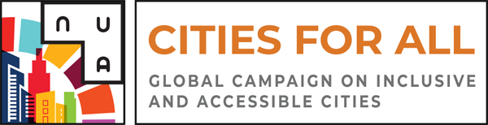
The Global Compact on Inclusive and Accessible Cities is a declaration that aligns key commitments to accessibility, universal design and inclusion within The Sustainable Development Goals, The New Urban Agenda, The Convention on the Rights of Persons with Disabilities and the WHO’s Age Friendly Cities Initiative. It affirms the rights of 1 billion persons with disabilities and the increasing share of the global population aged 60 or older that experience barriers to their equitable participation in society.

The Global Compact helps cities understand the challenges facing persons with various types of disabilities, older persons, and other key stakeholders. Signatory cities, organizations and individuals of the Global Compact share common commitments to addressing challenges and realizing the opportunities to ensure local governments leave no one behind. They also commit to implementing local actions and policies to advance #Cities4All. For more information, visit the Cities4All website.

WBU, ICEVI AND ONCE SIGN A COLLABORATION AGREEMENT TO ORGANISE GENERAL ASSEMBLY IN 2020
The World Blind Union (WBU) jointly with ONCE- Organización Nacional de Ciegos Españoles (Spanish Organisation of the Blind) and International Council for Education of People with Visual Impairment (ICEVI) will organise a global event on vision including the General Assembly of the WBU to be held in Madrid, Spain in 2020. Among key themes to be discussed at this major global event include: Sustainable Development Goals, UN Convention on the Rights of Persons with Disabilities (CRPD) and the Marrakesh Treaty.

Representatives of the three organizations: Dr. Fredric Schroeder (President of WBU), Mr. Miguel Carballeda (President of ONCE) and Dr. Frances Gentle (President of ICEVI) met in Madrid in November 2018 to sign a Memorandum of Understanding comprising the planning, organization, financing, and execution of the WBU/ICEVI Assembly. ONCE will host the event. More details will be available on the WBU website in due course.

WBU AND CBM SWITZERLAND DISCUSS FUTURE COLLABORATION

The CEO of World Blind Union, Mr. Jose Viera, recently visited CBM partners in Switzerland to review current partnership and how to work jointly in new projects for the benefit of members. Both organizations agreed that:
- Data collection is needed
- Humanitarian action and disaster risk reduction must be a priority
- National implementation and monitoring of SDGs and CRPD is critical.

INTERNATIONAL COUNCIL FOR EDUCATION OF PEOPLE WITH VISUAL IMPAIRMENT MESSAGE FOR WORLD BRAILLE DAY

Dr Frances Gentle, President of ICEVI shared the following congratulatory message upon UN recognition of the World Braille Day
"I am delighted with the news that the United Nations has passed a resolution designating January 4th each year as World Braille Day. If alive today, Louis Braille would be proud to celebrate his 210th birthday with the knowledge that more than 142 countries have adopted his code and 47 countries have prioritised creating and sharing accessible books across national borders through ratification of the WIPO Marrakesh Treaty and copyright reform.

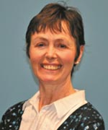 Dr. Frances Gentle, President of ICEVI

The challenge for ICEVI, World Blind Union, UN agencies, and the global education community is to promote policies and practices that bring education within the reach of children who are marginalised or disadvantaged as a result of their disability. This challenge includes reaching the 50% of girls and boys in developing countries who, like young Louis Braille, are confined to learning through listening as they have not been taught to tactually read or write.

ICEVI celebrates World Braille Day with our World Blind Union and World Braille Council partners. Together, we will promote braille as an essential enabler of access to education, employment and independence."

NORWEGIAN ASSOCIATION OF THE BLIND HANDS OVER WISHES TO GOVERNMENT

On World Braille Day staff and members of Norwegian Association of the Blind and Partially Sighted - Norges Blindeforbund (NABP) handed over their wishes, written in braille, to government officials. Among the wishes were request for zero value-added tax on NGO’s, the importance of braille and door-to-door transportation for the blind and other people with disabilities so they can live active lives.
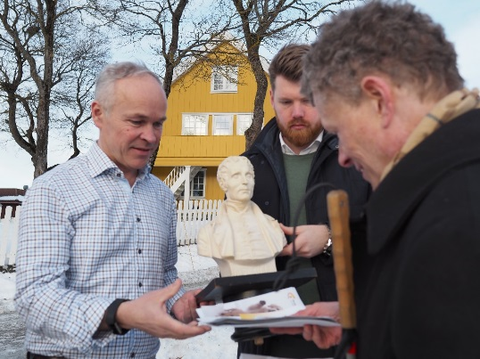 Chief of lobbying, Sverre Fuglerud handing over the Association's wishes to minister of education and integration

"Our people got to talk to both the minister of culture, Trine Skei Grande, as well as the minister of education and integration, Jan Tore Sanner. We handed over a few of our wishes for the new government's future policies, written in Braille. We also brought with us a bust of braille to tell the story of braille’s life and impact on our lives today", says Vegard Valestrand, Deputy Communications Officer of the NABP.

SWEDISH ASSOCIATION OF THE VISUALLY IMPAIRED DEMAND POLITICAL RIGHTS

The Swedish Association of the Visually Impaired (SRF) demanded that Swedish political parties should make their information materials accessible and that the Swedish state should ensure that election to the European parliament in May is fully accessible by offering braille for the ballots. SRF made these demands in commemoration of the World Braille Day, January 4.

DANISH ASSOCIATION OF THE BLIND EMPHASIZES IMPORTANCE OF BRAILLE

To mark the World Braille Day, John Heilbrunn, Vice-President of the Danish Association of the Blind shared the following message:

"France is mostly acknowledged by blind persons for having a citizen, Louis Braille, who almost 200 years ago invented the braille font. This was the first time that blind persons were able to truly read, write and communicate amongst themselves. It was a liberating way for the blind to learn to use a system that was adapted for their specific use by sense of touch.

It took time before countries around the World, like Denmark, to acknowledge that braille was the indisputably most suitable and manageable way to communicate for blind persons. But now it is, and using technology in an innovative way can lead to boosting and enforcing the production, use and circulation of braille through high speed embossers, notetakers, braille displays etc.

Sighted persons are subject to graphics, letters and other such stimuli constantly. Blind persons are not. Therefore, it is of ultimate importance to keep up braille at all levels starting with parents learning, cherishing and playing braille into the lives of their kids, who with this as a basis, will have a much greater opportunity to become educated and even obtain employment.

That the UN has now fortified the focus on braille by recognizing the Birthday of the inventor, Louis Braille, on January 4, means that braille should be acknowledged, supported and given prime priority at all levels, from the international level down to national and local level."

SUBMISSIONS FOR THE LIGHTHOUSE’S ANNUAL $25,000 PRIZE ARE OPEN

The LightHouse’s annual $25,000 prize for ambitious blind people, the Holman Prize, is open for submissions.

The Holman Prize provides financial backing for three blind individuals pursuing a project of their own design over the course of a year. These proposals may involve travel, community organizing, athletics, creating art and more. Six winners with diverse projects that span from African beekeeping and blind world travel resources to physical feats like kayaking and extreme triathlons have been funded since the launch of the prize in 2017.

The process begins with a challenge: blind applicants must submit a first-round pitch, in the form of a 90-second YouTube video. Submissions for the 2019 Holman Prize close on February 28th, 2019 at 12 Noon Pacific Standard Time. Any and all eligible blind adults worldwide are encouraged to apply, even if they’ve applied previously.
More information about the application process can be found on the Holman Prize website.

DOLPHIN COMPUTER ACCESS ANNOUNCES FREE EASYREADER APP FOR TALKING BOOKS

UK assistive technology developer, Dolphin Computer Access, has worked with the Royal National Institute of Blind People (RNIB) to enable blind and partially sighted people to access the charity’s Talking Books library using Dolphin’s EasyReader app, completely free of charge.

Alongside a comprehensive list of book and newspaper suppliers, people with sight loss can now browse, borrow and download talking books from the RNIB’s library on their smartphone or tablet with EasyReader. The EasyReader app is available on both iOS and Android devices. For more information visit Dolphin’s website.

FIRST WORLDWIDE SURVEY OF AUDIO DESCRIPTION ACTIVITY CONDUCTED

A new international survey reveals that audio description (AD) is an important assistive technology worldwide providing access to people who are blind or have low vision to the arts and many other visually-rich events.

The new AD survey finds that:
- 67% of respondents said that AD is available in the respondent’s country;
- cinema, television, live performing arts, and DVDs lead the list of the type of AD experiences available (followed by museums, the web, smartphones, in educational settings and in visitors’ centers);
- almost 45% said that AD is required by law (64% of those respondents reported that it was required for broadcast television); and
- 99% of respondents said that they believe AD or more AD should be available.​
The Full report is available on the WBU website.

WBU PARTICIPATE AT UN WORLD DATA FORUM

World data experts met in Dubai in October to discuss innovative solutions to improve data on migration, health, gender and many other key areas of Sustainable Development Goals (SDGs).

Over 80 sessions and parallel events including discussions around the theme: "Leaving No One Behind: The challenge and promise of disability disaggregated data"; National Data Platforms for SDGs Reporting and SDGs Data Challenges and Opportunities.

The forum was attended by representatives from international data sectors of national statistical offices, the private sector, NGOs, academia and international and regional organizations. The WBU was represented by the Chief Executive Officer, Mr. Jose Viera.

320,000 TITLES AVAILABLE FOR CROSS-BORDER EXCHANGE IN EU
WIPO (World Intellectual Property Organization) is delighted to announce that with the implementation of the EU Marrakesh Treaty Directive and Regulation in France, Poland, and The Netherlands, the ABC Global Book Service now has over 320,000 titles available for cross-border exchange without the need to request permission from the copyright owner. This total represents the catalogues of 13 AEs located in Australia, Canada and the EU, respectively. For more information, contact Monica Halil Lövblad, Head, Accessible Books Consortium (ABC) at monica.halil@wipo.int

FEATURES

MEET AMBA SALELKAR, A YOUNG LAWYER AND DISABILITY ACTIVIST BASED IN CHENNAI, INDIA​
By Terry Mutuku, Communications Officer, World Blind Union​

To commemorate International Day of Persons with Disabilities, we interviewed Amba Salelkar, a lawyer and disability activist based in Chennai, India

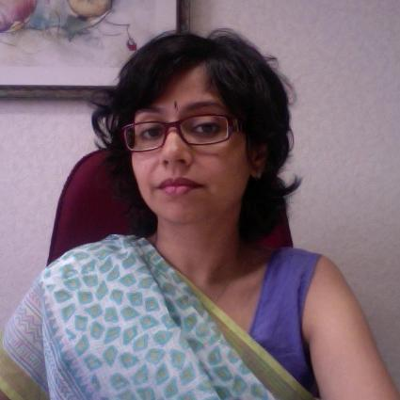Amba Salelkar, lawyer and disability activist

Q: Can you tell us a little bit about yourself and your work?
A: I am a law graduate. I worked in criminal trial litigation in Mumbai here in India. I later moved on to Chennai, to take up another job with the Inclusive Planet Centre for Disability Law and Policy. Currently, I am working for Equals Centre for Promotion of Social Justice where me and my colleagues focus on bridging the gap between disability movement and evidence law, based on the UN Convention on the Rights of Persons with Disabilities (CRPD).

Q: Would you like to tell us about your disability?
A: I have been living with mental health impairments since I was 20 years old. It is a combination of depression, panic attacks and anxiety. I had a particularly severe crisis in 2012 following an altercation with a judge in court. Because of that, I faced a lot of stigma and negative attitude. I couldn’t go back to work. I had to take time off to recover as well.

When I was recovering, I started looking for some research work to do. I was put in touch with Rahul Cherian, a Lawyer and disability policy maker, founder of Inclusive Planet Centre for Disability Law and Policy who had done a lot of work on the rights of the visually impaired around intellectual property rights and the “right to read”. He had also participated in the negotiations around the Marrakesh treaty. At that time he was looking for a research assistant for the parallel reporting process. It was a coincidence that he asked me to look at the Mental Health Law, he had no idea of my condition. That was the first time I read the UN Convention on the Rights of Persons with Disabilities (CRPD). I learnt a lot; about reasonable accommodation, accessibility, inclusiveness, participating on equal basis, etc. It all made a lot of sense to me. This helped me through my recovery process.

He then offered me a job at the Inclusive Planet Centre for Disability Law and Policy, where I worked for two years, though he suddenly passed away a year after I started working with him.

Working in the disability sector as a person with disability is very interesting. I use my own experience to reach out and help others in advocating for their rights.

Q: This year's theme for international day of people with disabilities is "Empowering persons with disabilities and ensuring inclusiveness". What is the significance of this theme?
A: I think that the theme is all about awareness of disability rights among the disabled and the able bodied as well. Everybody needs support regardless of whether you have a disability or not. The theme also encourages inclusiveness, the idea that disability is part of human diversity. We need to take steps to ensure people with disabilities are included in development agendas. We need to promote inclusiveness and equality. We are looking for an inclusive society for everyone. We need to talk about inclusiveness and equality as a basic human right. It is important to recognise specific rights about people with disabilities.

Q: What have been some of the key challenges you’ve faced and the lessons you have learnt with regard to promoting the inclusion and equality of persons with disabilities?
A: I have had to learn a lot about my own understanding of what reasonable accommodation and accessibility means for me. I am from upper middle-class family with some privileges, and because my impairment manifested itself when I was already in law school my experience is quite different. This is something as an activist I have to be aware of because my experience is not as of others who may not be privileged. Some people don’t believe my disability experience, because I am perceived to privileged. Senior activists have accused me of ‘faking’ my disability, because it is an invisible condition. It can be emotionally draining. So self care is something I prioritize.
Addressing the inclusion of people with disabilities within the global development agenda is crucial. We in the disability movement, and especially women with disabilities, should be able to articulate our issues, and be heard. We need to do something and do something fast and inclusively so that "no one is left behind".

Q: With regard to the Convention on the Rights of Persons with Disabilities (CRPD) what do you think has been one of the greatest milestones in the disability rights movement especially in India?
A: Signing of CRPD was a milestone in itself. In 2016, a new legislation on rights of persons with disabilities was passed by parliament and in 2017 the mental health care act was passed as well. This is part of the CRPD implementation process as the country prepares for review by CRPD committee in 2019. These are small but significant milestones, in implementing the CRPD to bring about changes. The CRPD is gaining traction, but there's more to be done to eliminate discrimination.

Q: What would you like to see in the future with regards to disability rights?
A: I would like to see more involvement of marginalised groups such as the deafblind and people with learning disabilities. We need empowerment of leaders from these groups, especially women. We also need to look at disability issues as intersectional issues that touch on other basic human rights such as accessibility.

Q: What helps you to achieve success as a lawyer?
A: I enjoy doing what I love, and this is a motivation in itself. Through the disability movement I have met so many people, and shared experiences and learnings. It is so much fun learning and sharing with others. I always learn something new from each encounter.
Q: Can you tell us about your future goals?
A: I am monitoring and looking at how disability laws are going to unfold in India. We in the disability movement will monitor and use whatever tools we have to demand accountability. We want to develop simple, universal tools that everyone can use so that we are not missing out on voices from the marginalised. We want to use good practices from other parts to reach out to rural groups. I look forward to this personally.

Also, I just finished a training of trainers on disability rights which I hope to take forward especially with women with disabilities from the global south.

Q: What advice can you give to other women who are living with disabilities?
A: For me, independence does not mean you don’t need support. It doesn’t mean you are not a strong or complete person. Everyone needs support. Women with disabilities should understand that support is a basic human right, and we should have a say about the kind of support or quality of support we need. We need to embrace who we are, our identity and demand our rights.

Read WBU's statement for international day of persons with disabilities on our website

RESOURCES

IMPLEMENTING THE MARRAKESH TREATY - A PRACTICAL GUIDE FOR LIBRARIANS

EIFL co-launched a new practical guide to the Marrakesh Treaty for persons with print disabilities during the International Federation of Library Associations and Institutions (IFLA) World Library and Information Congress that took place in Kuala Lumpur, Malaysia.

The new guide, titled ‘Getting Started. Implementing the Marrakesh Treaty for persons with print disabilities. A practical guide for librarians’, is mainly aimed at librarians in countries that have joined the Marrakesh Treaty, and where national implementation is completed or advanced. Download full guide on WBU website​.

PROJECT ASPIRO

SUCCESS STORIES ON EMPLOYMENT
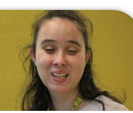
Caren Burns, a Trainee Library Officer at Vision Australia
We are pleased to present the story of Caren Burns, a Trainee Library Officer at Vision Australia. In this interview, Caren describes how she captured a traineeship at the Vision Australia Library where she is currently working. Watch the video on the WBU Project Aspiro website

Visit the Project Aspiro website regularly for more inspiring success stories and resources about employment, education and career planning. We invite you to share your stories and inspire thousands of others around the world. Please tell us how blindness or low vision impacts day to day life, challenges and successes. You can submit a short video or audio (about 3-5 minutes). The preferred format for an audio file is an mp3 file. Videos files may be submitted in any of the following formats: .MOV, .MPEG4, .AVI, .WMV, .MPEGPS, .FLV, .3GPP, or .WebM. See more details on the Project Aspiro website or contact terry.mutuku@wbu.ngo.

UPCOMING EVENTS

WORLD READ ALOUD DAY

Blind SA in conjunction with Nal’ibali and South Africa Braille Authority will host World Read Aloud Day on 21 February 2019. The event will promote the culture of reading and writing in braille using mother-tongue languages.

The event is organized in commemoration of International Braille Day on 4 January; World Read Aloud Day on 1 February; and International Mother-Tongue Language Day on 21 February. Special Schools for the Blind and other mainstream schools for blind and partially sighted learners from grades 4 to grade 7 are invited to the event. For more information, contact: Busi Monyamani on pa@blindsa.org.za

REMINDER: CONTACT INFORMATION

Friendly reminder to members: Please check your contact information on our website to ensure that it is up to date at: Member Regions and Organizations: http://www.worldblindunion.org/English/about-wbu/membership/Pages/Member-Regions-and-Organizations.aspx
Should you change your contact information any time please update us. You can contact Ianina at ianina.rodriguez@wbu.ngo

PICTORIAL NEWS
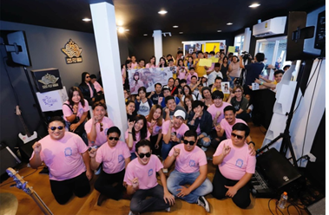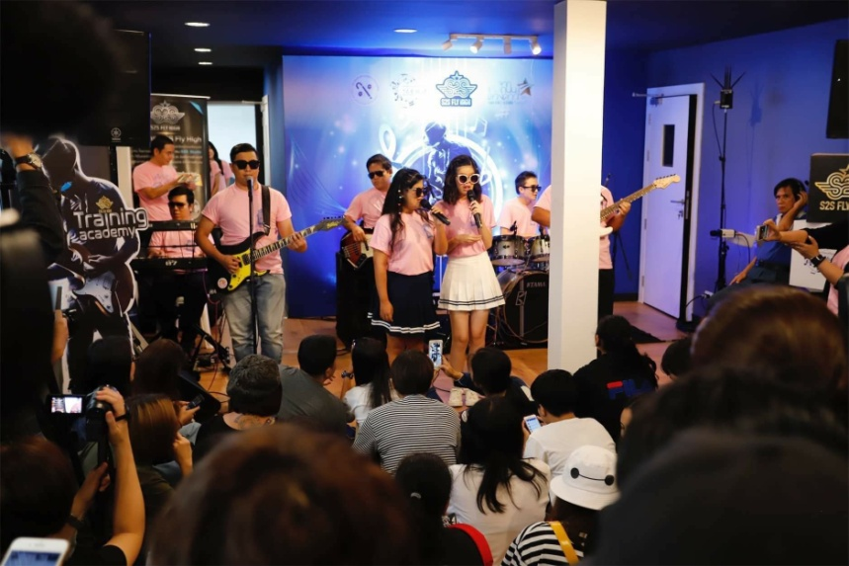

The Thailand Association of the Blind Music Academy Foundation (TABMAF) cooperating with the Thailand Association of the Blind (TAB), The LittleFinger group and Thai volunteer, Thai artists organized the event “Sending the picture we see through the voice you hear” at the National Center of the Blind in honour of the “White Cane Safety Day”, on 15th October last year.

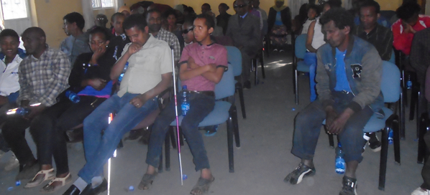

Members of the Ethiopian National Association of the Blind (ENAB) congregated to celebrate the World Braille Day, January 4.

LETTERS TO THE EDITOR
We welcome comments, feedback and new ideas to be featured in this section of Letters to the Editor. Those who want to comment on articles published in the newsletter can do so.

Brief letters with a maximum of 500 words will be considered. They must be submitted within the contributions deadline provided in each issue. Letters will be edited, usually for grammar, spelling, clarity and space. Every effort will be made to publish the letters and replies if any. However, the choice of letters for publication is at the discretion of the WBU office, subject to content and space. You can send your letters to Terry.Mutuku@wbu.ngo

THE WBU REGIONS
Our regions are the bridge between the international level of work and the local level. Policies and treaties constructed at global levels are then carried out by our members in their own countries. Most of the regions have their own websites where they post updates on their work, member activities, and upcoming events in their area.

AFRICA
http://www.afub-uafa.org

ASIA
Website is currently unavailable

ASIA-PACIFIC
http://wbuap.org/index/

EUROPE
http://www.euroblind.org

LATIN AMERICA
http://ulacdigital.org

NORTH AMERICA/THE CARIBBEAN
Website is currently unavailable

WBU TABLE OFFICERS
Dr. Fredric K. Schroeder, President
president@wbu.ngo
Mr. Fernando Riaño
1st Vice President
friano@ilunion.com

Ms Donatilla Kanimba
2nd Vice President
donakanimba@gmail.com

Ms. Martine Abel-Williamson Treasurer
martine.the1@xtra.co.nz
Mr. A. K. Mittal
Secretary General
mittal24ak@gmail.com
Mr. Arnt Holte
Immediate Past President
arnt.holte@blindeforbundet.no

REGIONAL PRESIDENTS

AFRICA (AFUB)
Mr. Yaw Ofori-Debra
yawdebra2015@gmail.com

ASIA (ABU)
Mr. Santosh Kumar Rungta nfbsec.g@gmail.com

ASIA PACIFIC (WBU-AP)
Ms. Michiko Tabata
tabacchi@par.odn.ne.jp

EUROPE (EBU)
Mr. Wolfgang Angermann ebupresident@euroblind.org
LATIN AMERICA (ULAC)
Mr. Volmir Raimondi
presidencia@ulacdigital.org

NORTH AMERICA/CARIBBEAN (WBU-NA/C)
Mr. Charles Mossop
charles.mossop@cnib.ca

WBU STAFF
Mr. Jose Viera
Chief Executive Officer
jose.viera@wbu.ngo

Ms. Terry Mutuku Communications Officer
terry.mutuku@wbu.ngo
Jessica Kashia Jacobie
Human Rights Officer
Jessica.Jacobie@wbu.ngo
Ms. Ianina Rodriguez Administrative Assistant Ianina.rodriguez@wbu.ngo
Dard, Benjamin
Global Accessibility Advisor Benjamin.Dard@cbm.org
Hannes Lagrelius, Program Officer, Accessibility in Smart Cities Initiative
Hannes.Lagrelius@wbu.ngo

OUR SPONSORS
Members listed below provide funds beyond their membership fees to support the work of the World Blind Union. We are grateful to these members and organizations for their valued contributions.

Our Platinum Sponsors
- CBM International http://www.cbm.org/
- Canadian National Institute for the Blind (CNIB) http://www.cnib.ca
- Open Society Institute Foundation (FOSI) https://www.opensocietyfoundations.org/
- Organización Nacional de Ciegos Españoles (ONCE) http://www.once.es/new/
- Sightsavers International http://www.sightsavers.org
- Vision Australia http://www.visionaustralia.org/
- Vanda http://www.vandapharma.com/index.html

Our Diamond Sponsors
- Lighthouse San Francisco http://openhub.ch/en/content/swiss-federation-blind-and-visually-impaired
- Swiss Federation of the Blind and Sight Impaired (SFB) http://openhub.ch/en/content/swiss-federation-blind-and-visually-impaired
- Norwegian Association of the Blind and Partially Sighted (NABP) https://www.blindeforbundet.no

Our Gold Sponsors
- National Industries for the Blind (NIB) http://www.nib.org/about-us/mission
- Danish Association of the Blind (DAB) https://blind.dk/internationalt
- German Federation of the Blind and Partially Sighted (DBSV). https://www.dbsv.org/dbsv-in-english.html
*****
The World Blind Union is registered in Canada as a charitable organization in order to raise funds for our work. Donations from individuals or groups are always appreciated and can be made via the “Donate Now” button on our website: http://www.wbu.ngo.

